Year 8 |  | Transformations and Congruence | Non Calculator  Section
Skills and Knowledge Assessed:  - Describe translations, reflections in an axis, and rotations of multiples of 90° on the Cartesian plane using coordinates. Identify line and rotational symmetries (ACMMG181)  - Define congruence of plane shapes using transformations (ACMMG200)  - Develop the conditions for congruence of triangles (ACMMG201)  - Establish properties of quadrilaterals using congruent triangles and angle properties, and solve related numerical problems using reasoning (ACMMG202) |  |  | Name___________________
Answer all questions in the spaces provided on this test paper by:
Writing the answer in the box provided.
Completing a drawing in the space provided.
or
Shading in the bubble for the correct answer from the four choices provided.
Show any working out on the test paper. Calculators are not allowed.
Use geometric instruments to draw the image after ABCDE is translated in the direction and distance of the arrow.
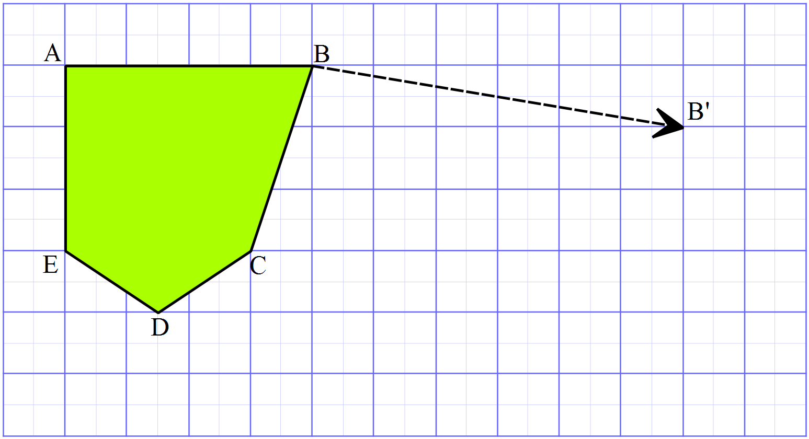

Which is not always true of two congruent triangles.

The corresponding angles are equal in size.
The corresponding sides are equal in length.
Their areas are equal.
They are both right angled.

Questions 3 and 4 refer to the diagram below.
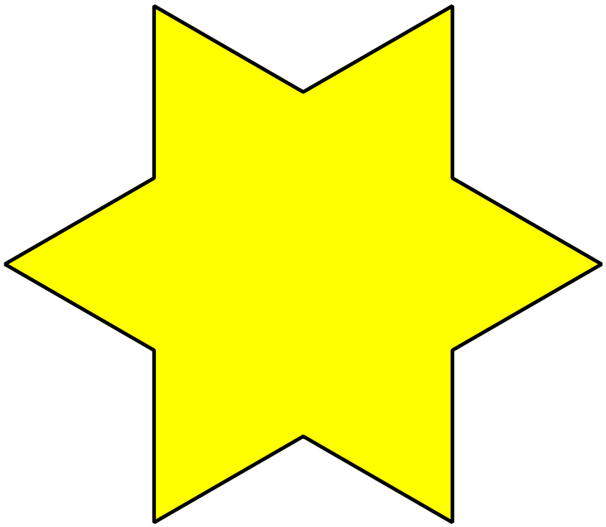

 | Draw all the axes of line symmetry on the shape.
What order of rotational symmetry does the shape have?

Order 2 Order 3 Order 6 Order 12
 | 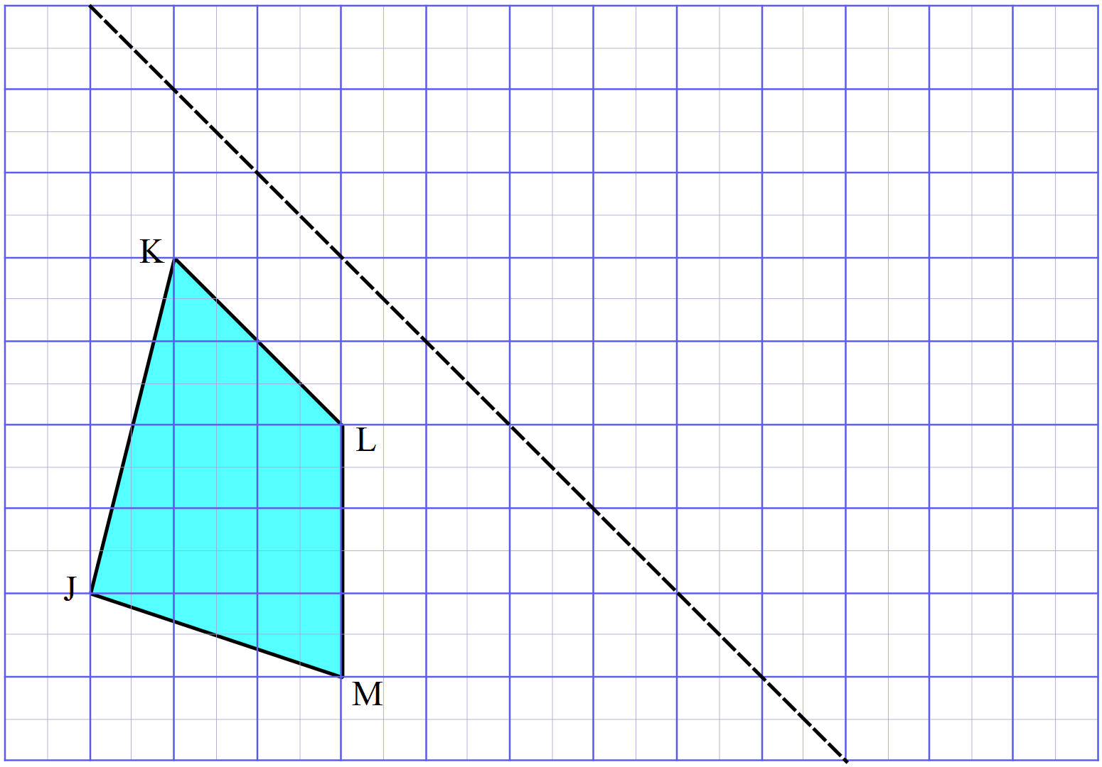Use geometric instruments to draw the image after JKLM has been reflected in the dotted line.
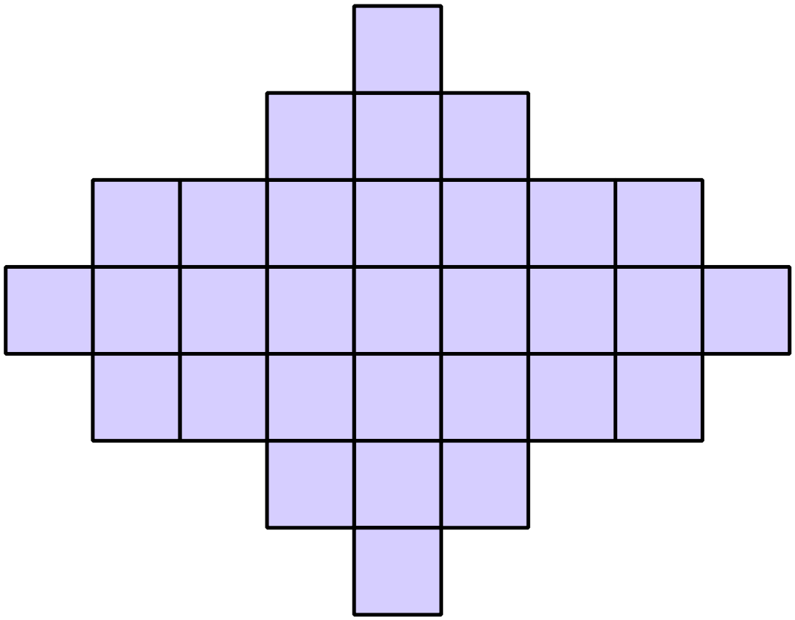What order of rotational symmetry does the shape below have?

2 4 6 8
Use geometric instruments to draw the image after PQRS is rotated through 120º in a clockwise direction about O.
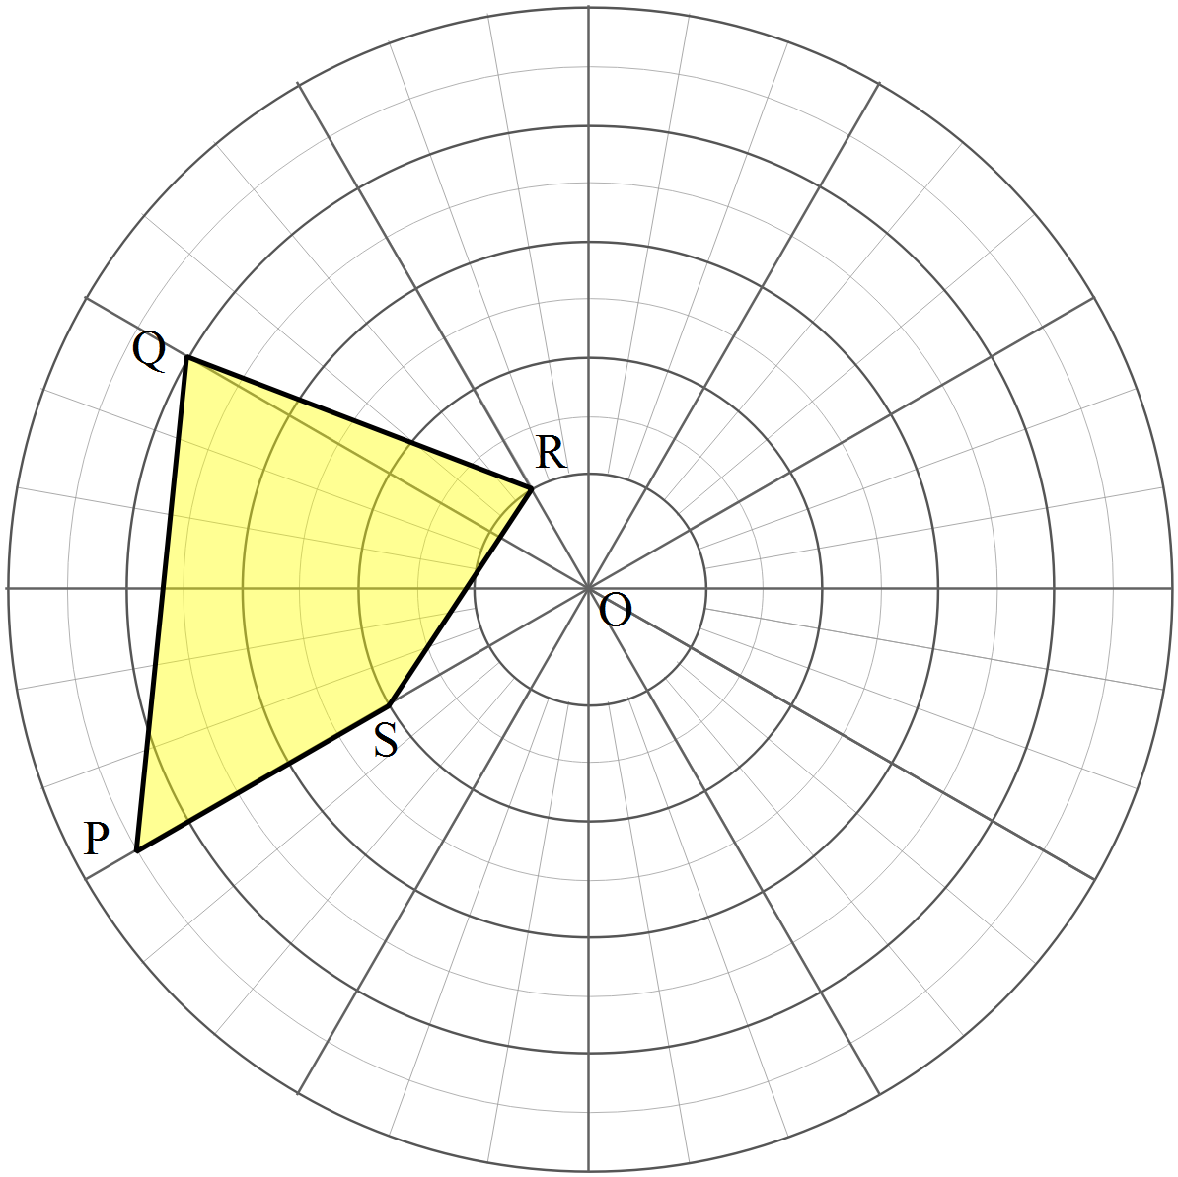

The triangle OPQ is rotated through 90º in an anticlockwise direction about O.
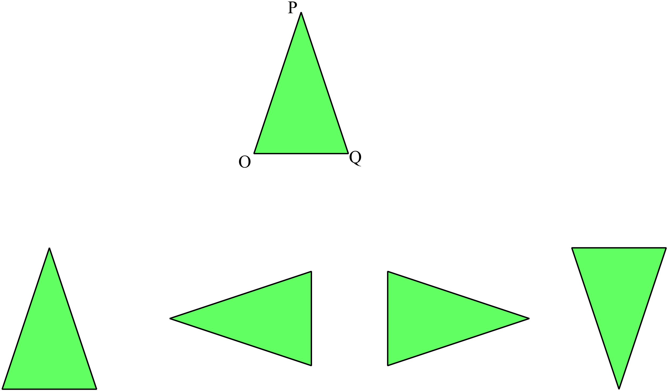
Which triangle could be the image?

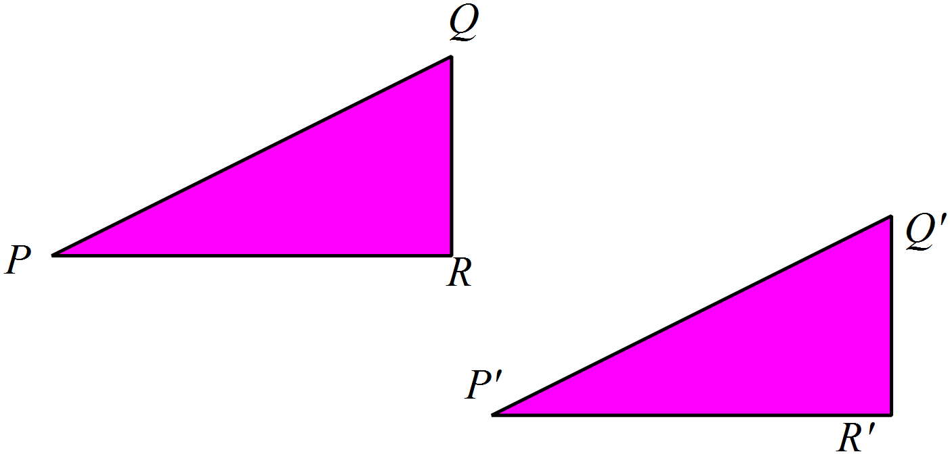The figure PQR could be transformed to the figure 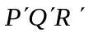 by:

Rotation through 180º.

Reflection.

Translation.

Rotation through 90º.

Which polygon has rotational symmetry of order 7?
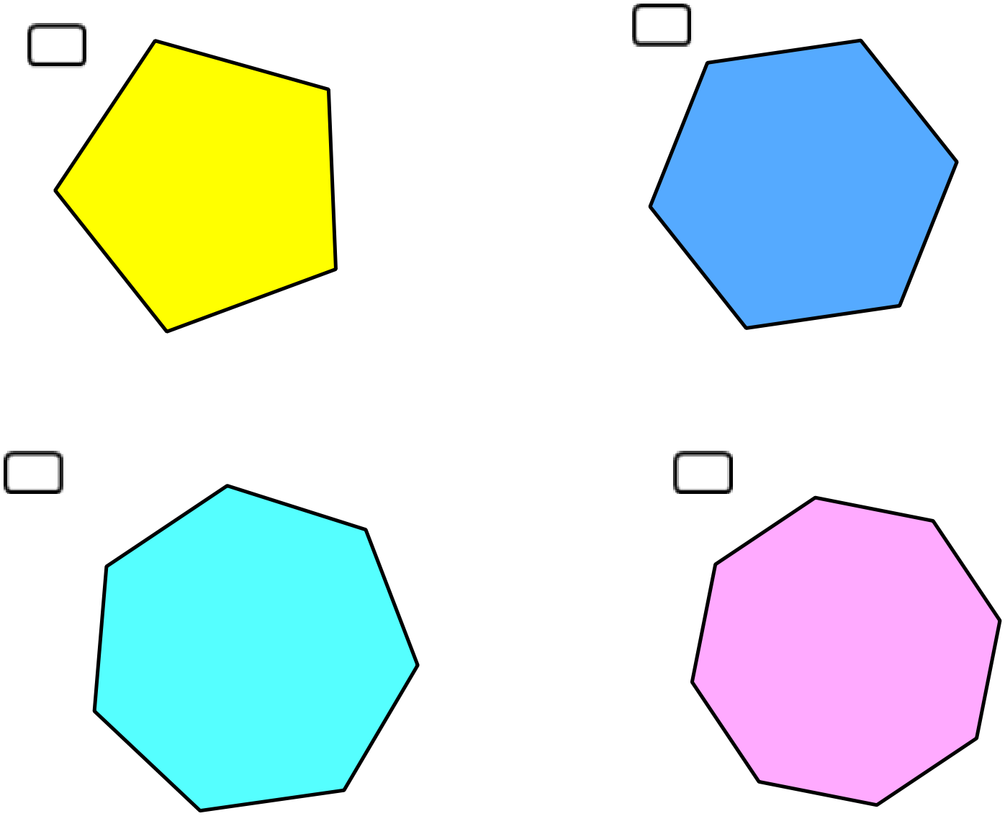

Complete the figure given that PQ is an axis of line symmetry.
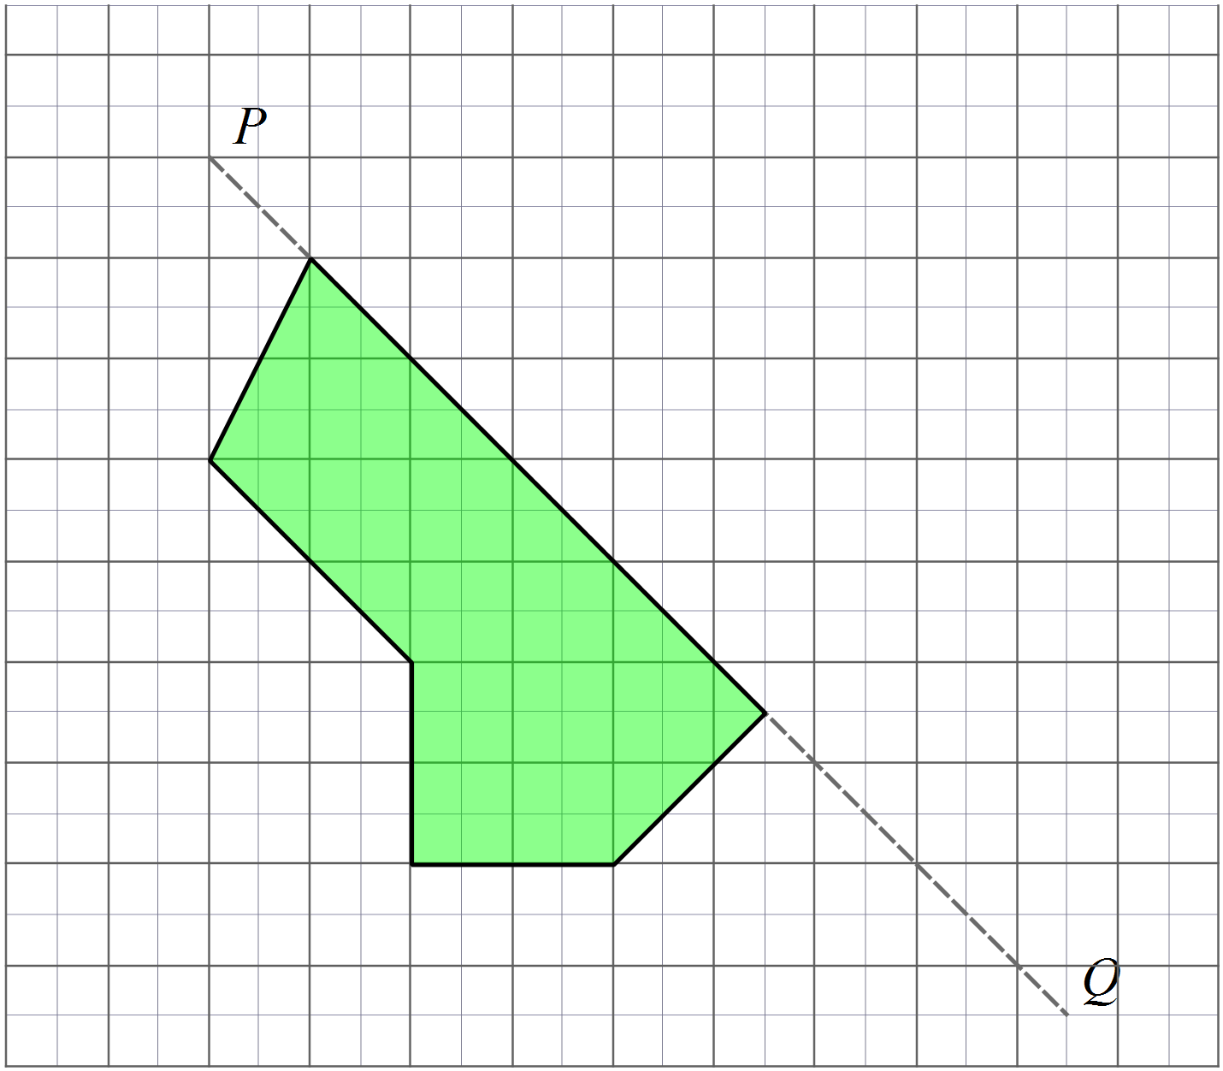

Which transformation creates an image which is congruent to the original, but which has the order of the vertices reversed? (e.g. they are labelled clockwise in the original and anticlockwise in the image.)

A reflection. A rotation
A translation An enlargement

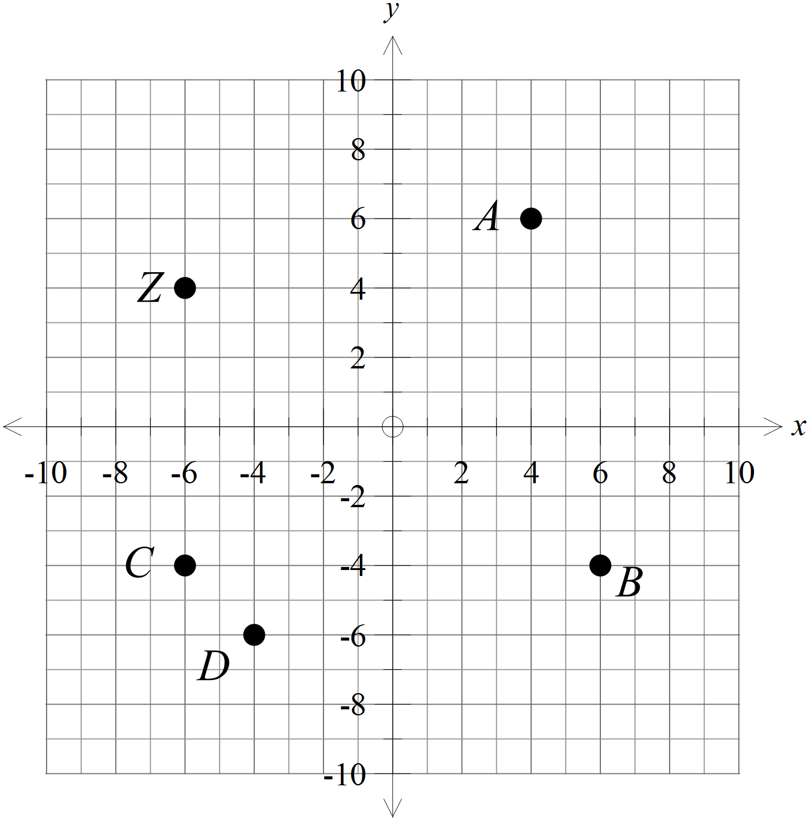The point Z (-6, 4) is rotated about the origin through 90º anticlockwise. Which point is the image after the transformation?

A (4, 6)

B (6, -4)

C (-6, -4)

D (-4, -6)

 | 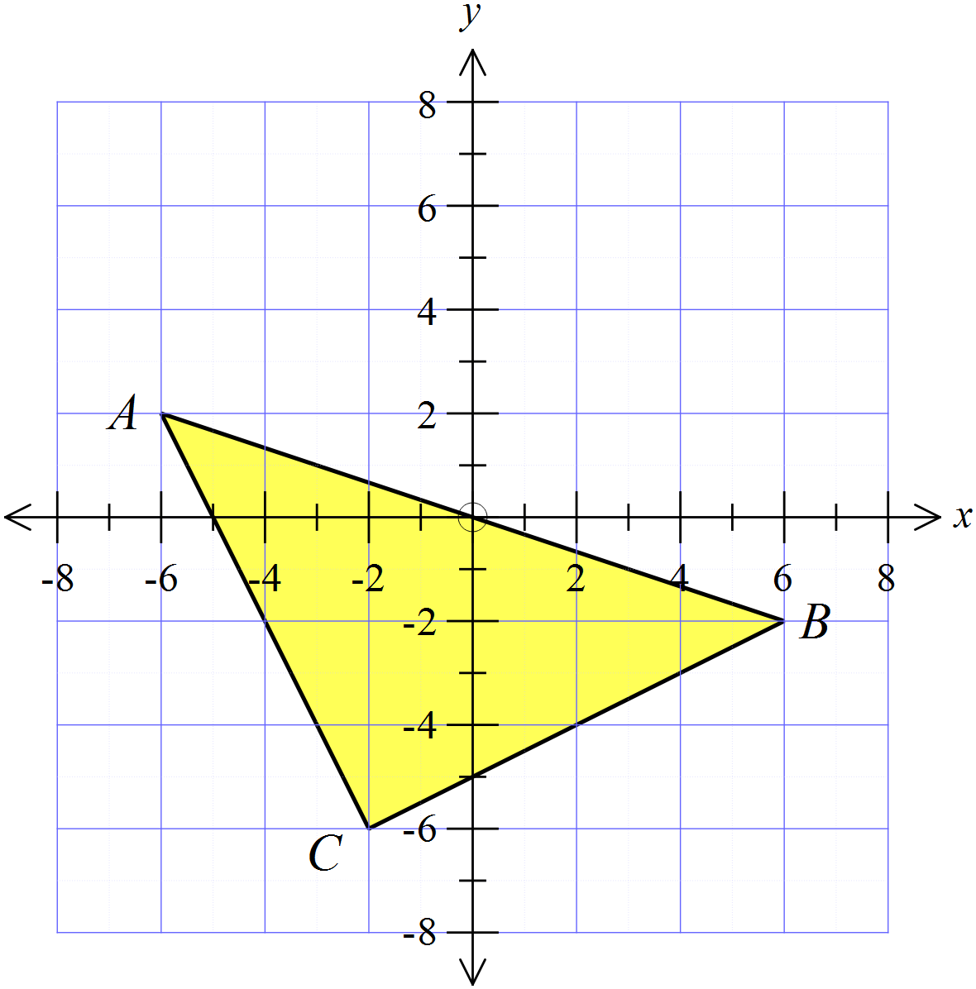Draw the image of triangle ABC after a reflection in the x axis.
The point M (-8, 6) is translated in the direction and distance indicated by the arrow.
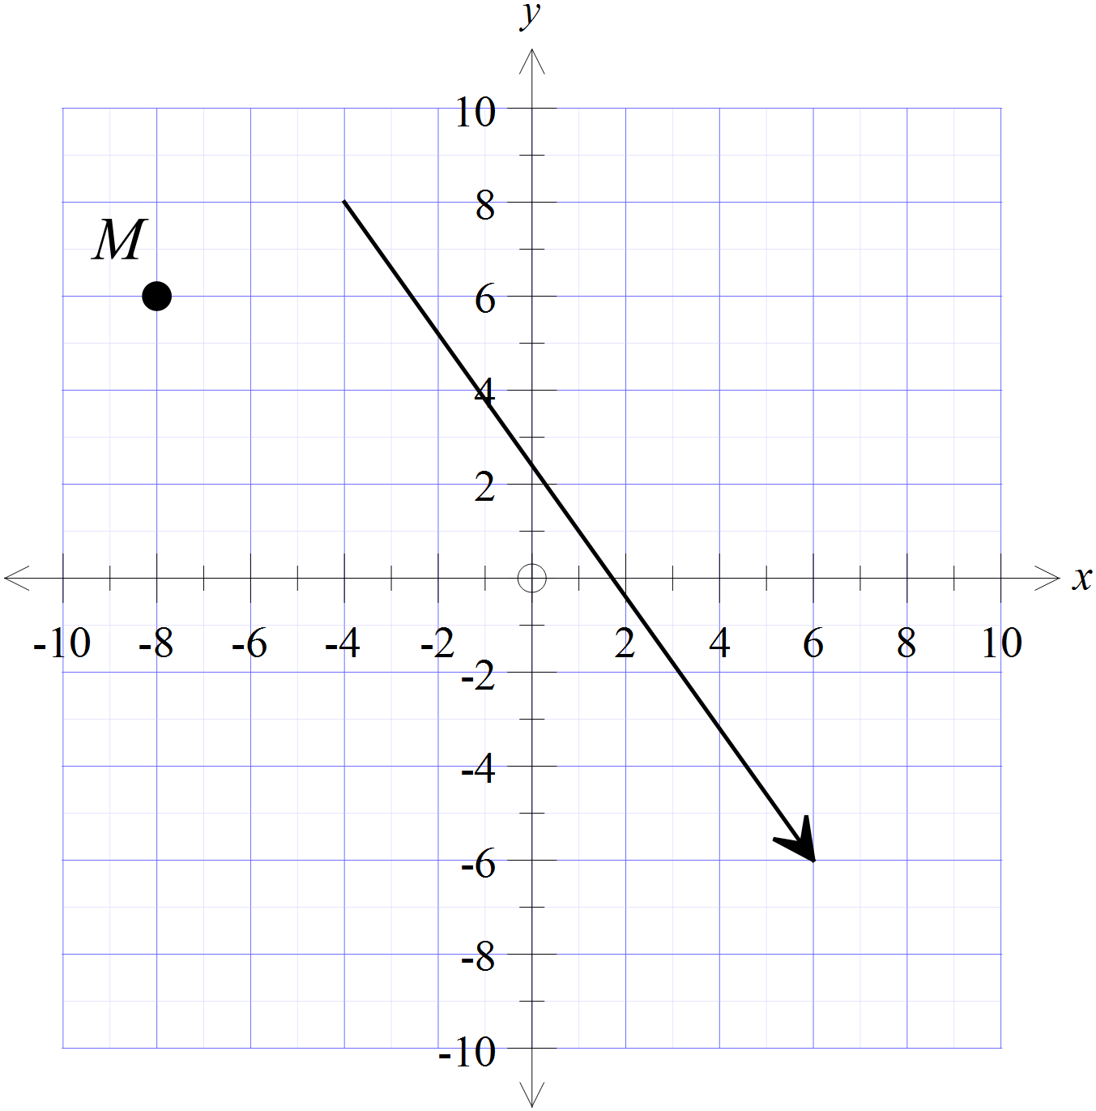Which are the coordinates of the image after the transformation?

HHlll

 | 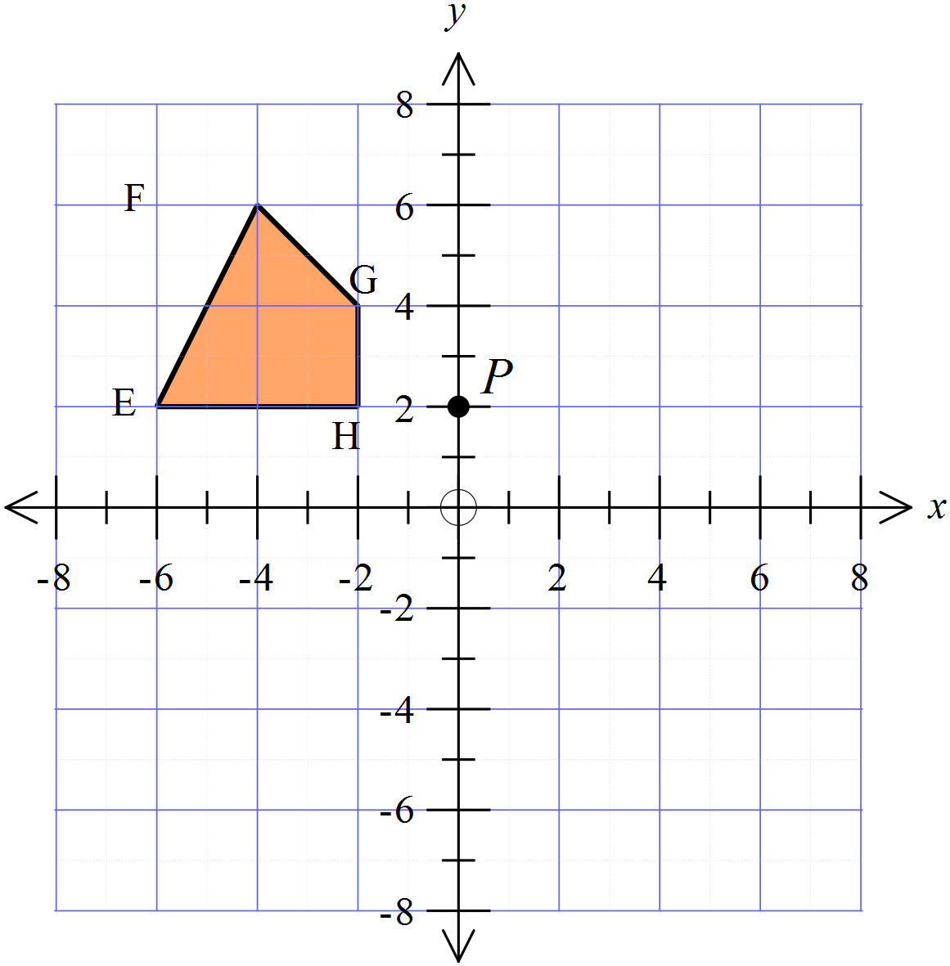Draw the position of the figure EFGH after a rotation through 90º in a clockwise direction about the point P( 0, 2)
The point M (-4, 5) is reflected in the line y = x.
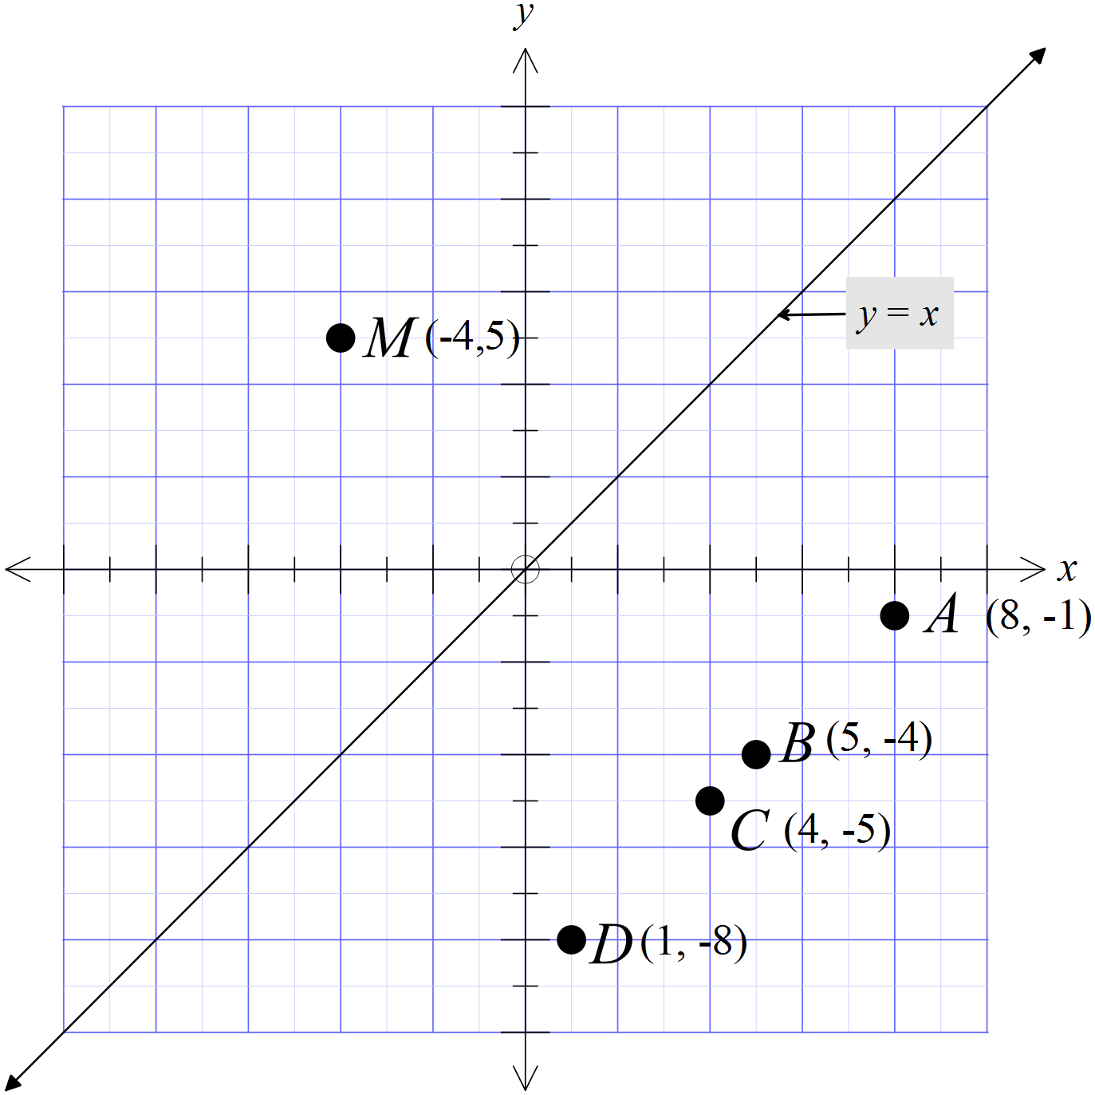Which point is the image after the transformation?

A (8, -1)
B (5, -4)
C (4, -5)
D (1, -8)

Figure ABCD is moved to an image A’B’C’D’ by a single transformation.
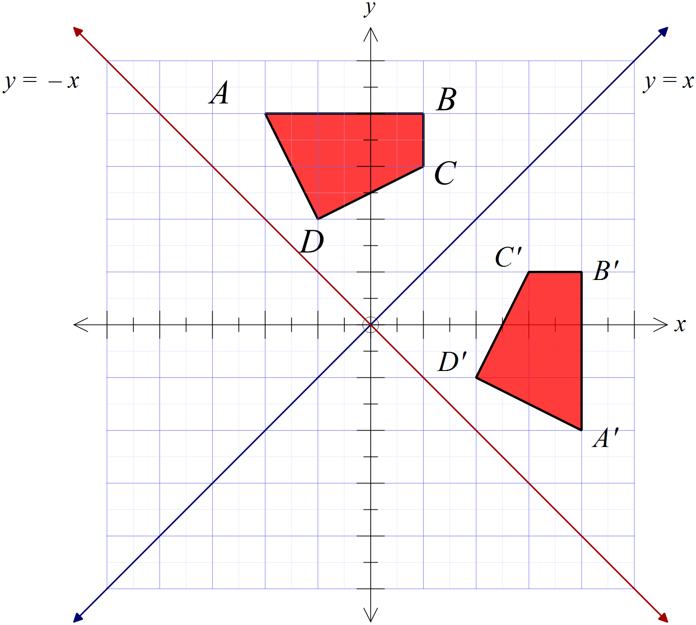What was the transformation?

A reflection in the line y = x.
A reflection in the line y = -x
An anticlockwise rotation of 90º about the origin.
A clockwise rotation of 90º about the origin.

Figure UVWX is moved to an image U’V’W’X’ by a single transformation.
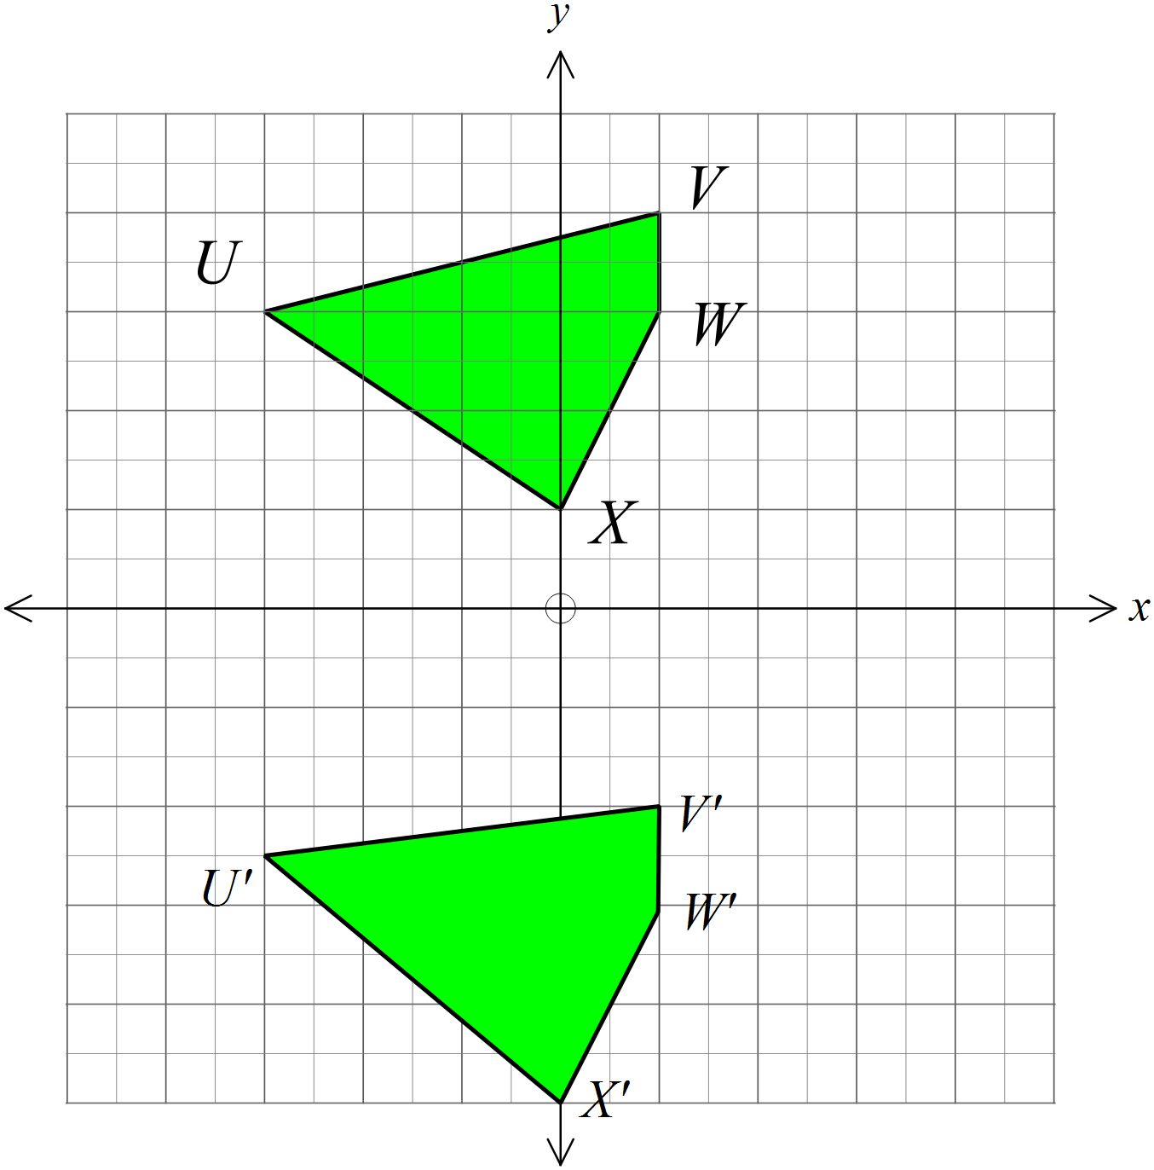What was the transformation?

A reflection in the x axis
A reflection in the y axis.
A rotation of 180º about the origin.
A translation downward along the y axis.

A kite ABCD has both its diagonals drawn, intersecting at E.
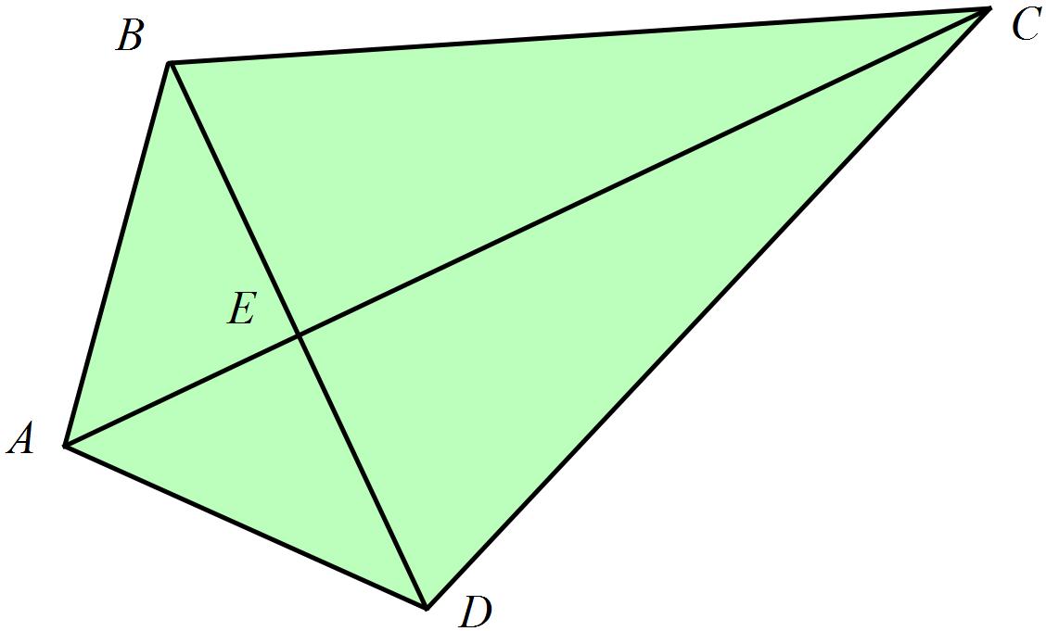
Which statement is true?

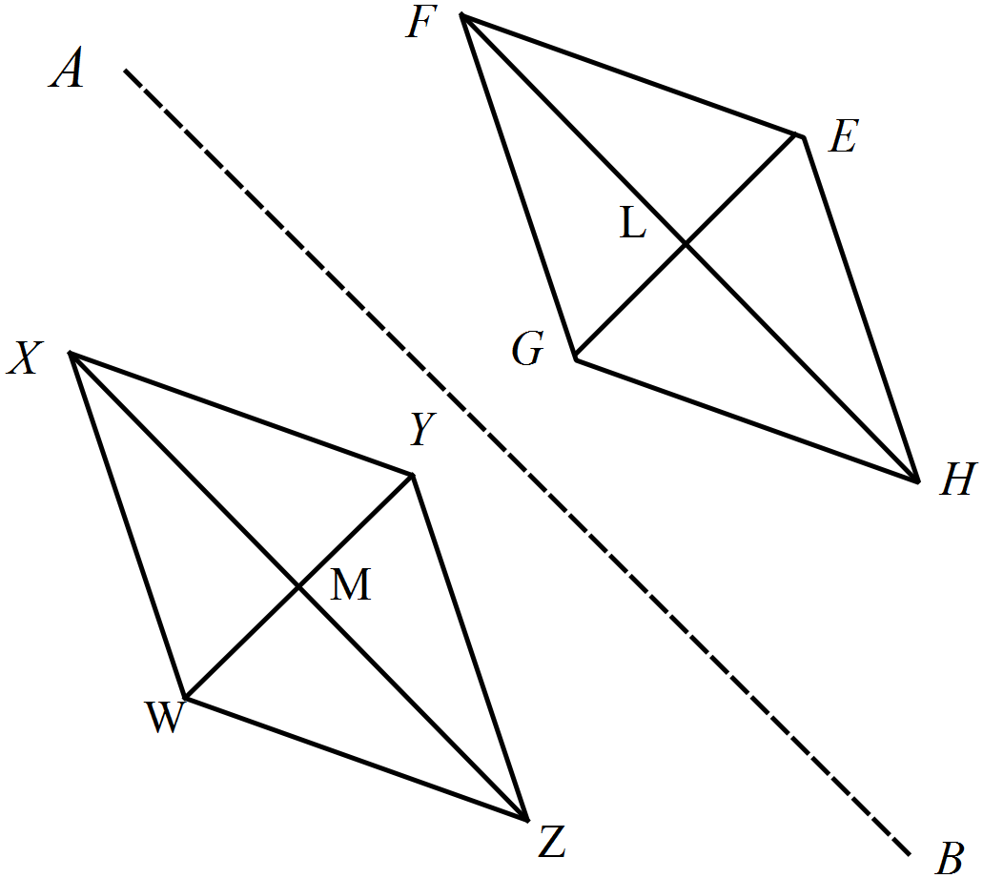The rhombus WXYZ is reflected in the line segment AB, to give the rhombus EFGH.

Which is not a pair of congruent triangles?

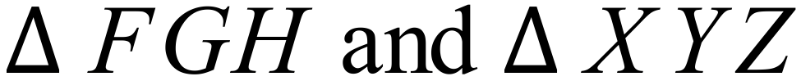
PQR is reflected in the y axis and then the image is reflected in the x axis.
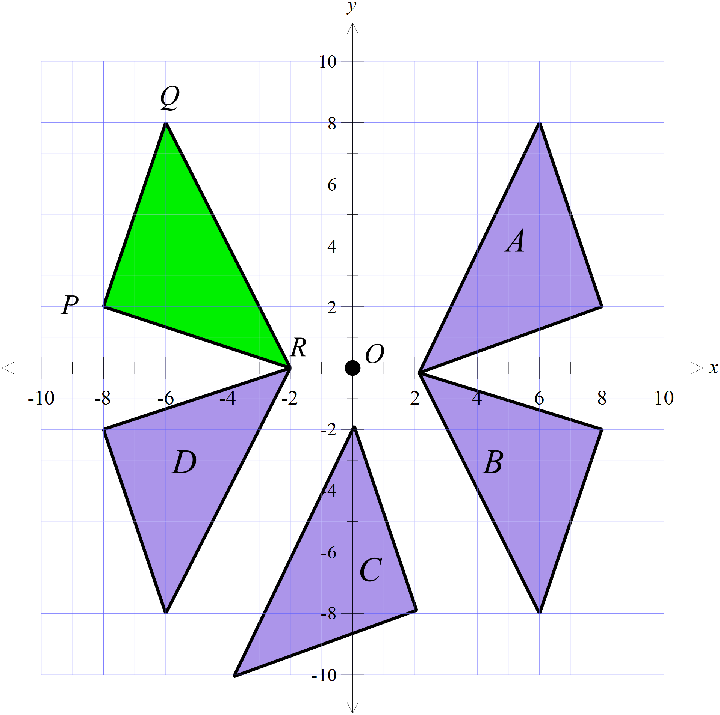
Which figure is its image?

Triangle A
Triangle B
Triangle C
Triangle D

Which of the congruence tests could be used to show that
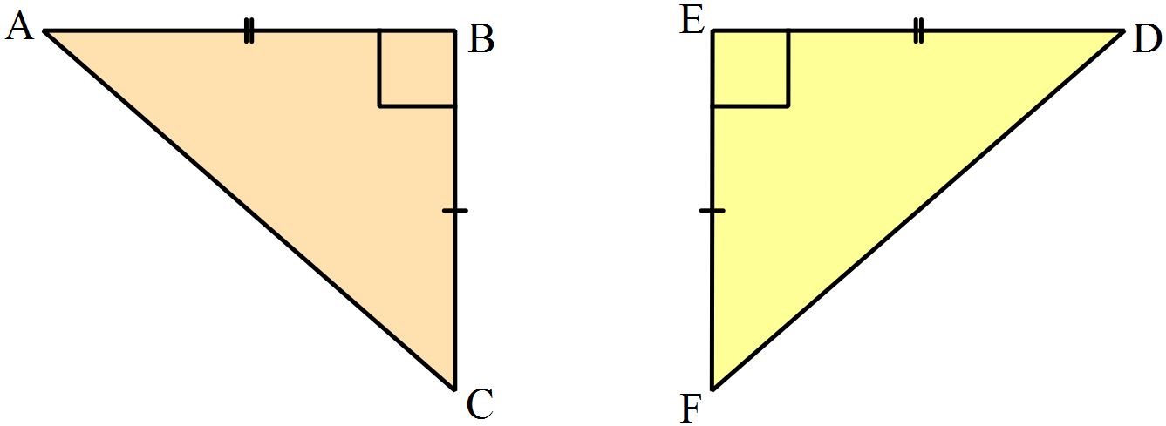

AAS RHS SAS SSS
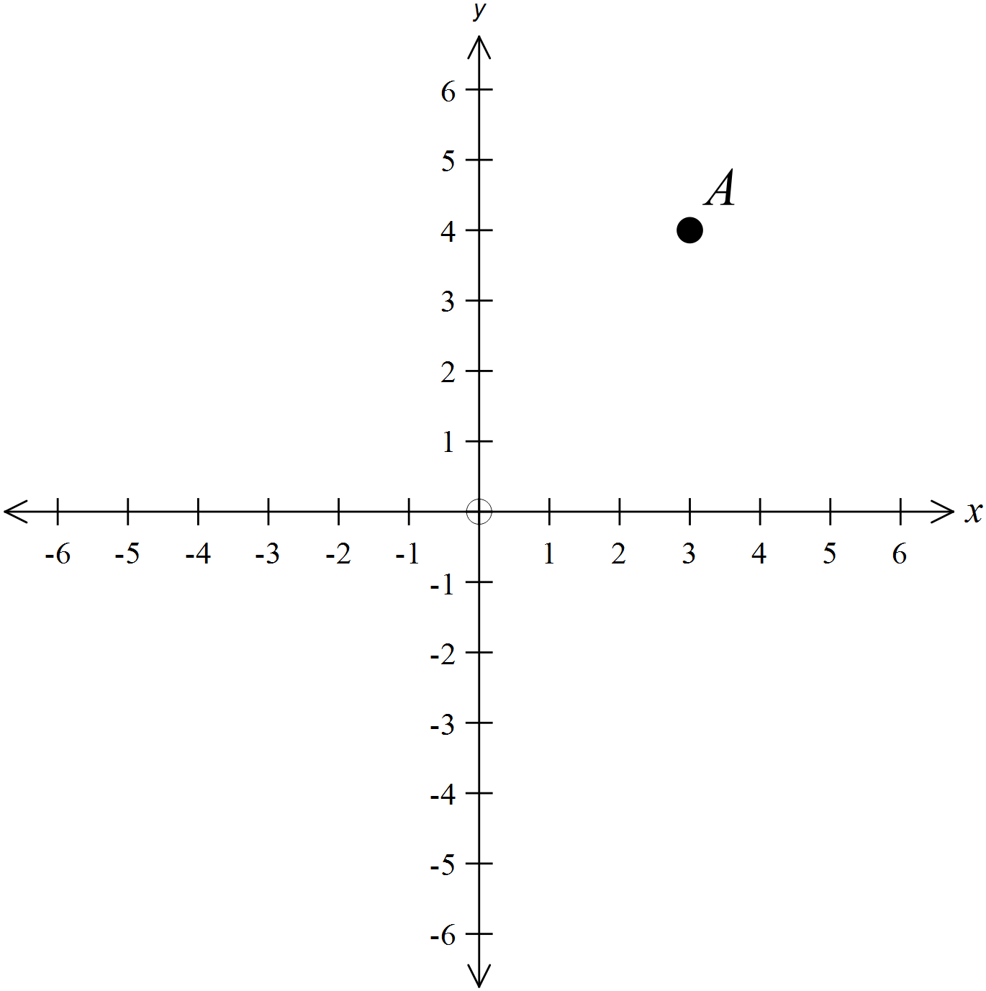The point A (3, 4) is rotated through 90º in a clockwise direction about the origin and then translated 8 units to the left and 7 units upward.
Give the coordinates of the point which is the image after these transformations?

( , ) )

In the figure below, BC = EF.
.
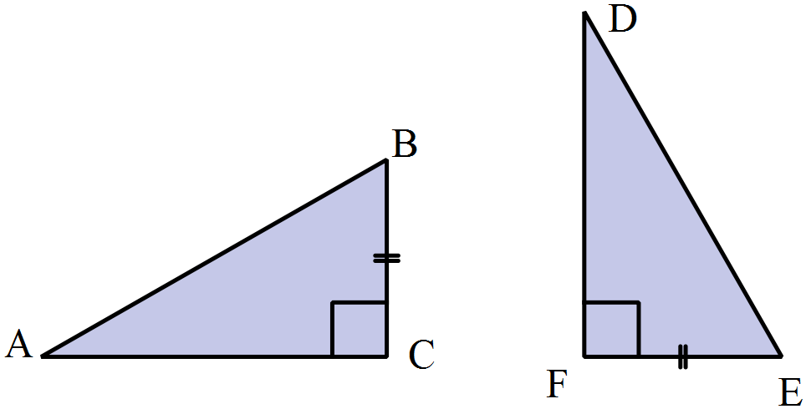Which single additional piece of information would allow you to show that

=

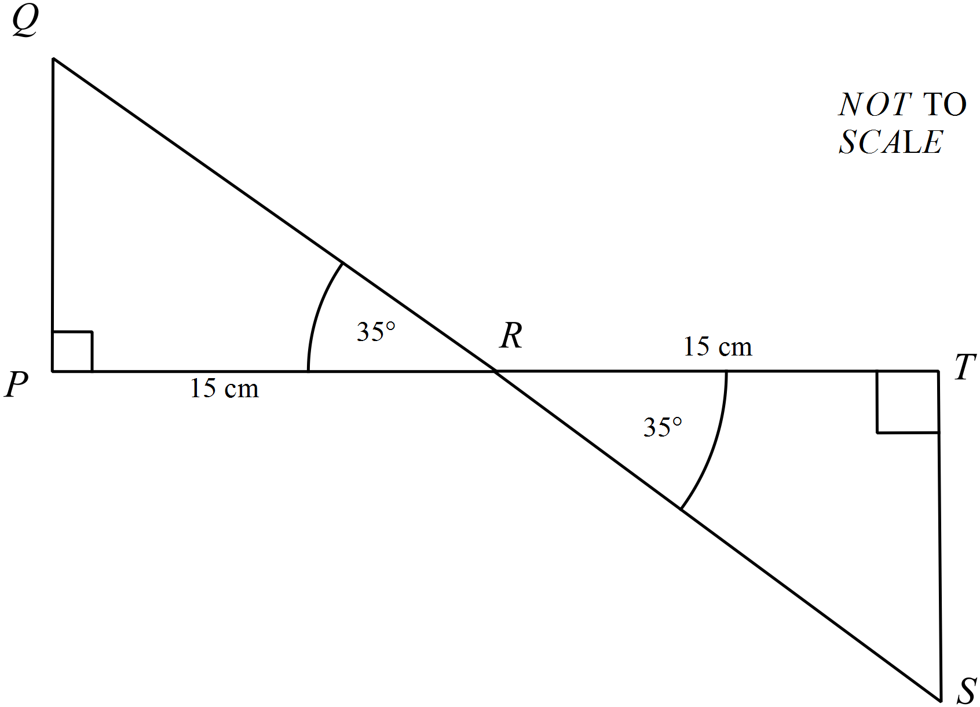
PR = TR = 15 cm
Which of the congruence tests could be used to show that
 ?

AAS
RHS
SAS
SSS
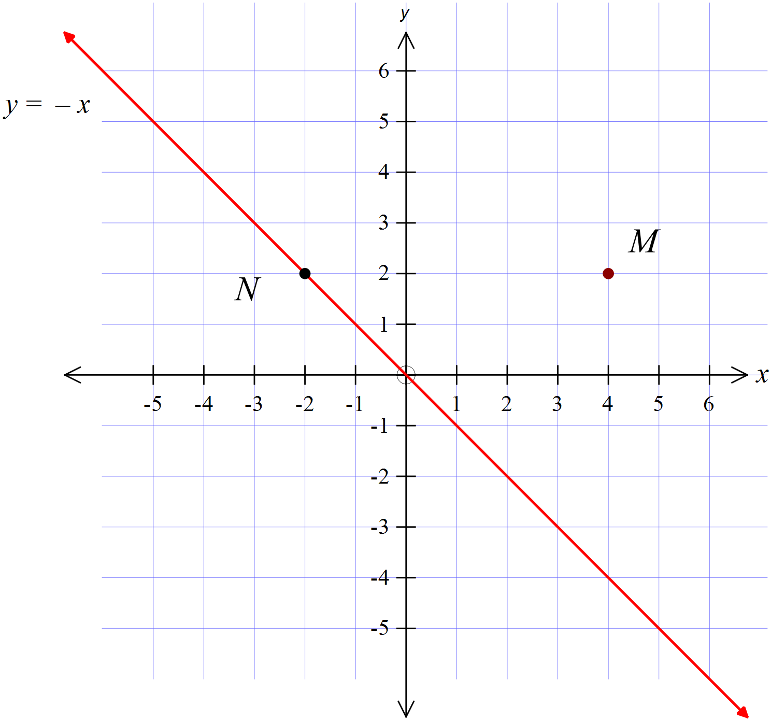The point M (4, 2) is reflected in the line 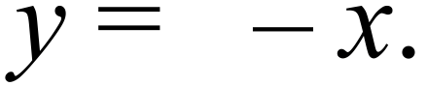
Describe the single translation which would then move the image to
N(-2, 2)?

)

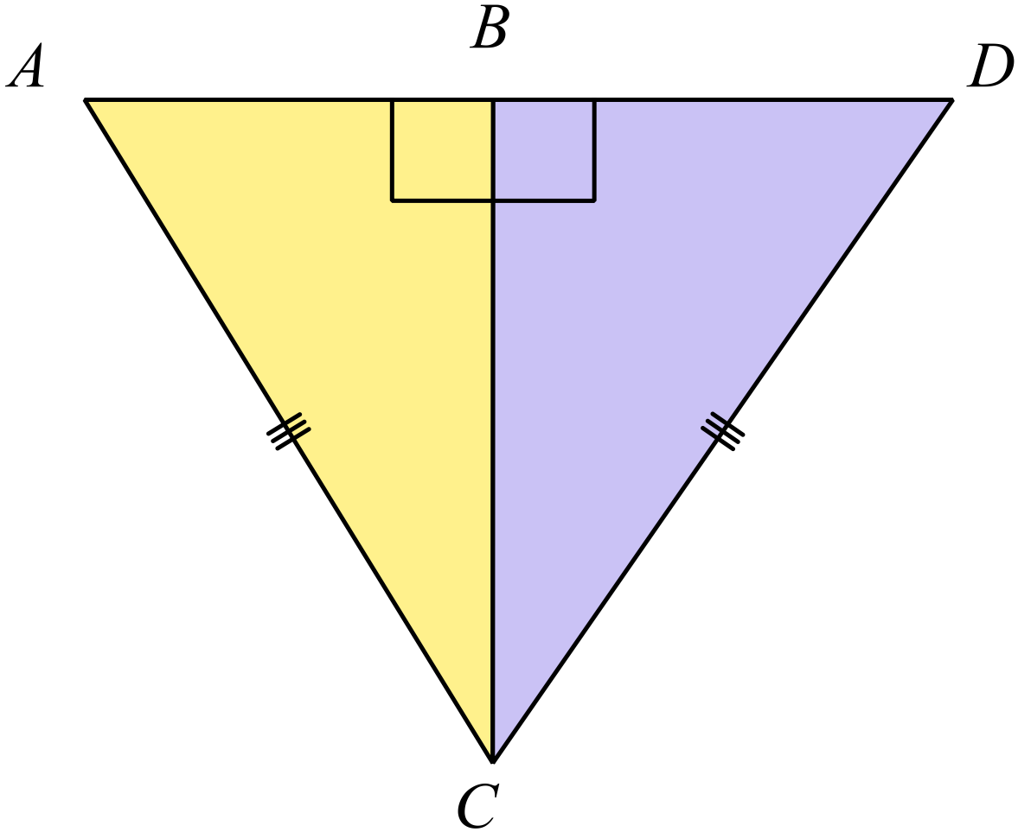Which of the congruence tests could be used to show that 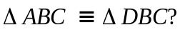.

AAS RHS SAS SSS

 | 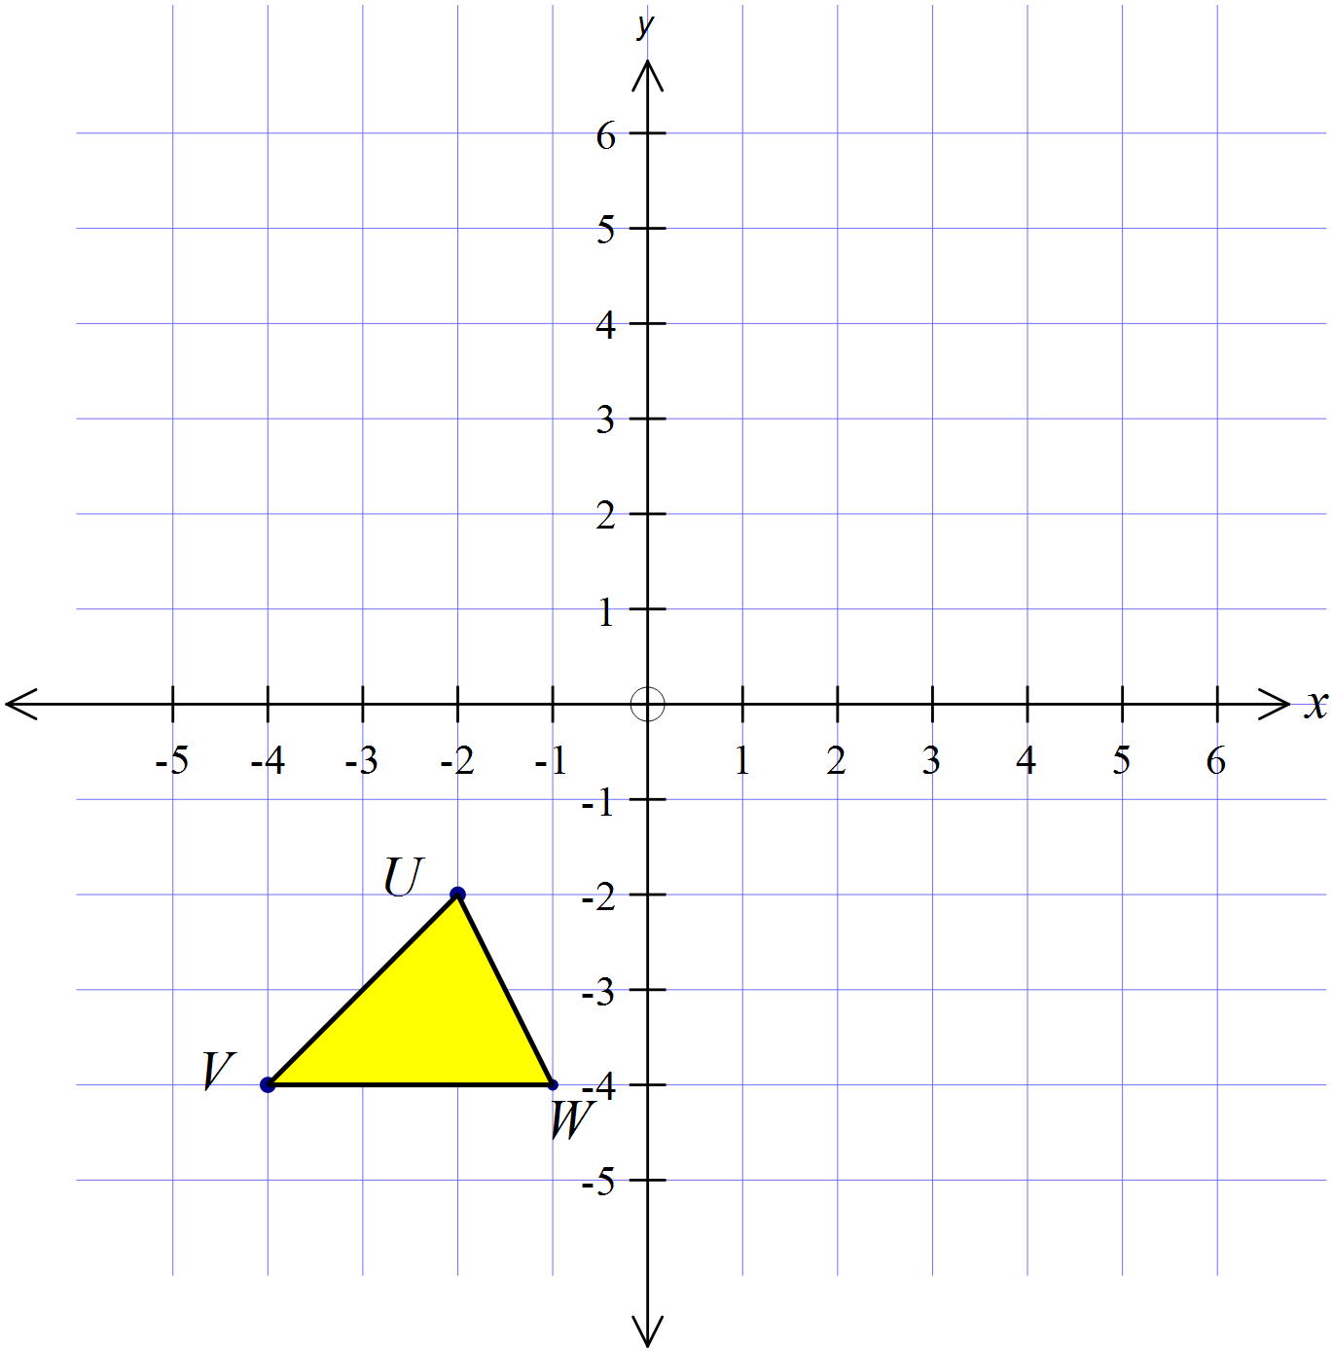The polygon UVW is rotated about the origin through 180º in a clockwise direction and then translated 5 units to the left. Draw the image U’V’W’ after these two transformations.
RU = SU
Which of the congruence tests could be used to show that
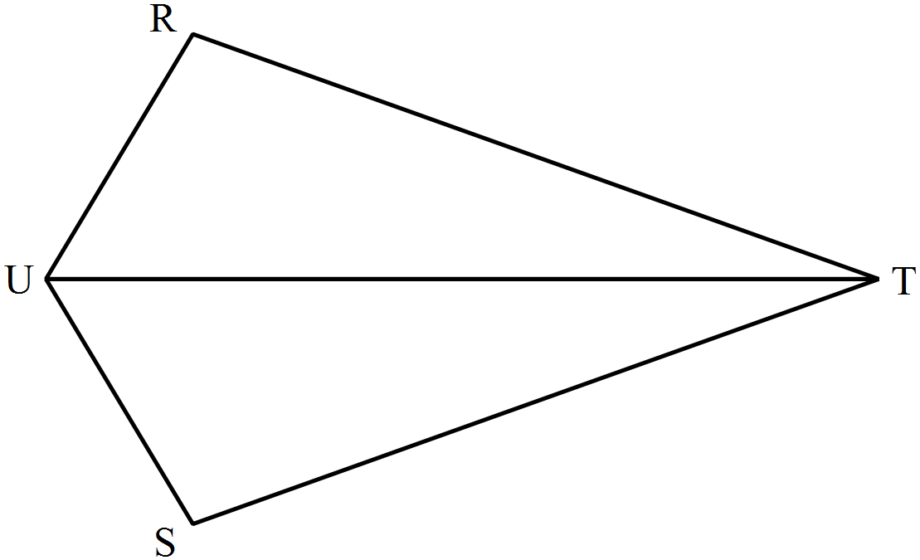

AAS RHS SAS SSS

Year 8 | Transformations and Congruence | Calculator Allowed  Longer Answer  Section
 |  | Name___________________
Write all working and answers in the spaces provided on this test paper.
Marks may not be awarded if working out and/or answers are not clear.
Marks allocated are shown beside each question.
Calculators are allowed.

 |  | Marks
 | (a) Draw the image of the trapezium NOPQ after a rotation through 180º about M.  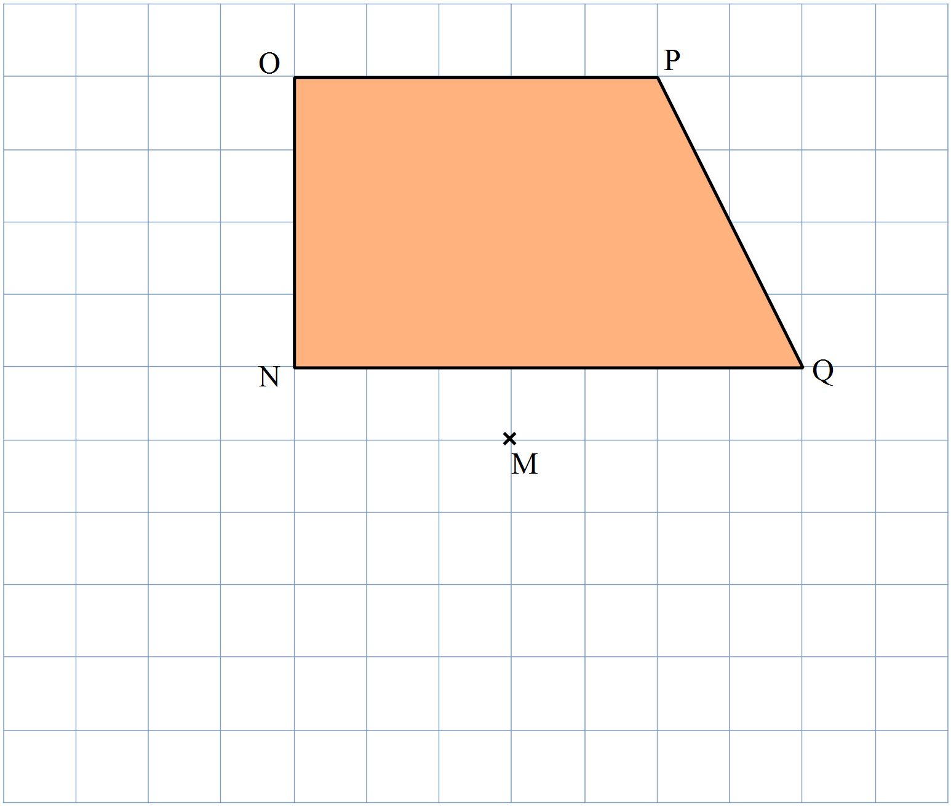  Use geometric  instruments. | 2
 | (b) (i) Part of a shape is shown. Complete the shape so that AB is an axis of line symmetry  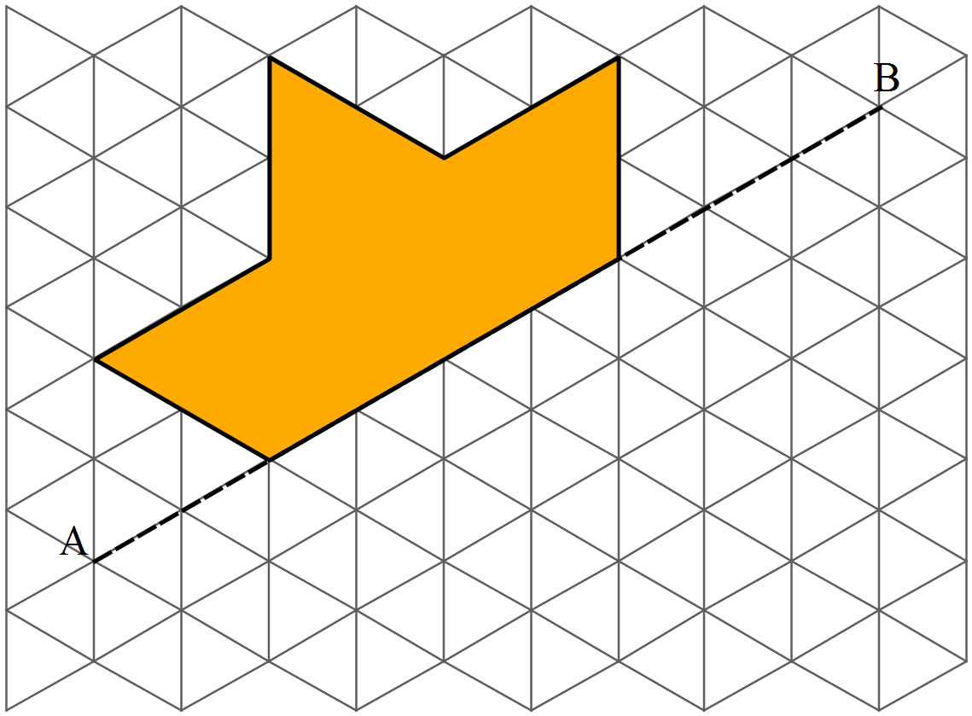  (ii) What order of rotational symmetry does the resulting shape have?  ____________________________________________________ | 2  1
 | (a) Draw a figure congruent to ABCD, by translating in the direction and distance indicated by the arrow.  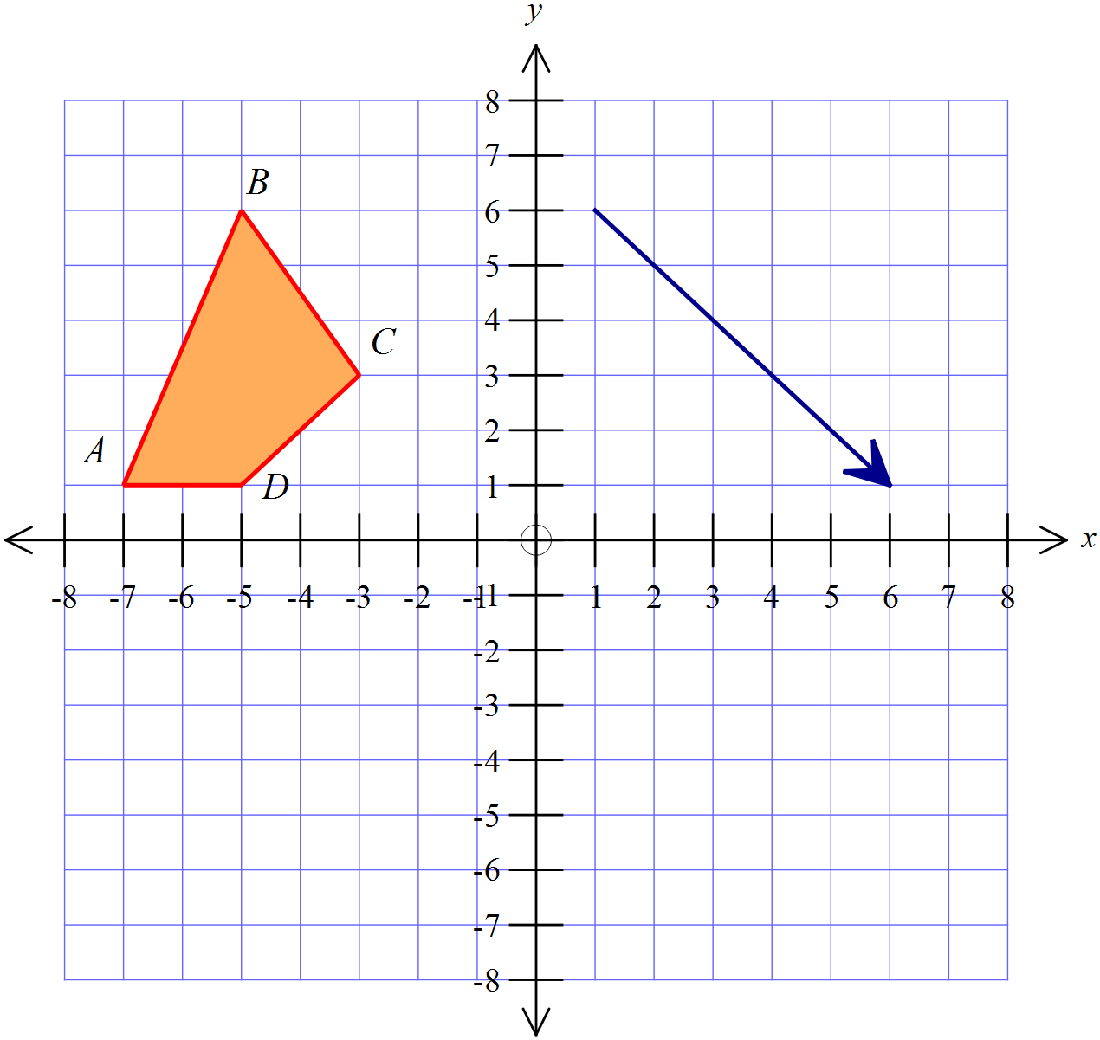 | 2
 | 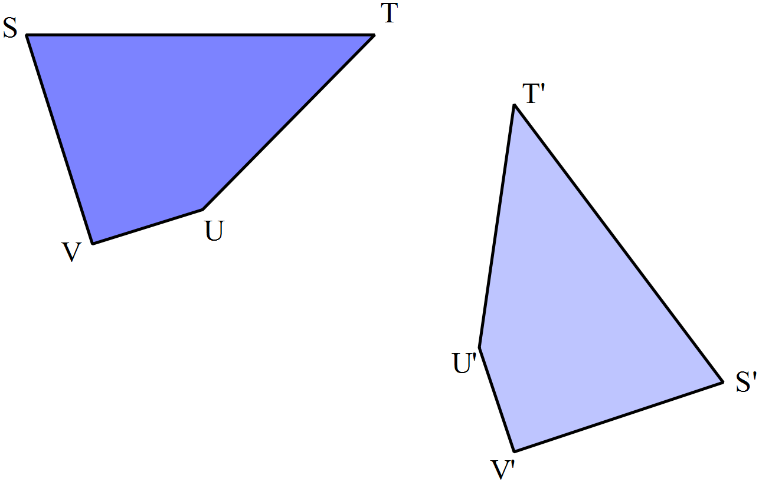(b)  Describe a single transformation that could move STUV to its image S’T’U’V’.  Add any additional lines or points to the diagram to illustrate your answer.  ……………………………………………………………………………………..  …………………………………………………………………………………….. | 2
 | (a) UW = XY, UV = XZ and .  Prove that  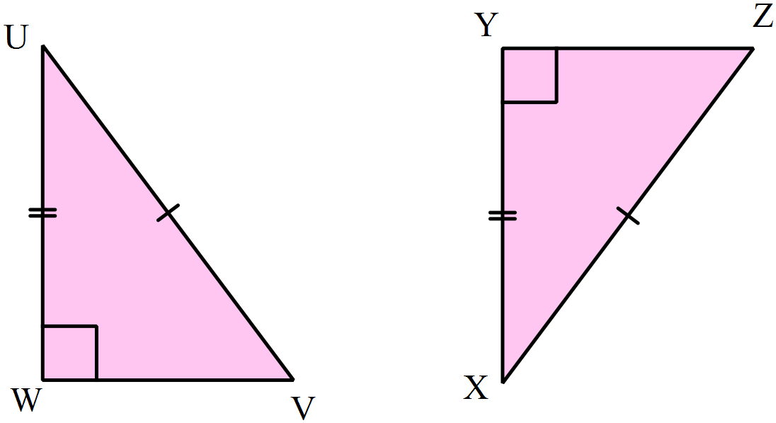  ……………………………………………………………………………………..  ……………………………………………………………………………………..  ……………………………………………………………………………………..  ……………………………………………………………………………………..  …………………………………………………………………………………….. | 2
 | (b) TS is a straight line segment, PT || SR and TQ = QS.  Prove that 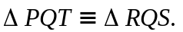  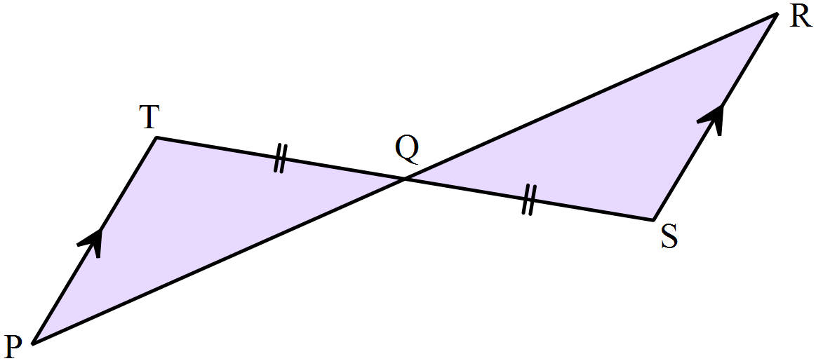  ……………………………………………………………………………………..  ……………………………………………………………………………………..  ……………………………………………………………………………………..  ……………………………………………………………………………………..  ……………………………………………………………………………………..  …………………………………………………………………………………….. | 3

Year 8 |  | Transformations and Congruence | Non Calculator  Section
ANSWERS
No. | WORKING |  | ANSWER
 | 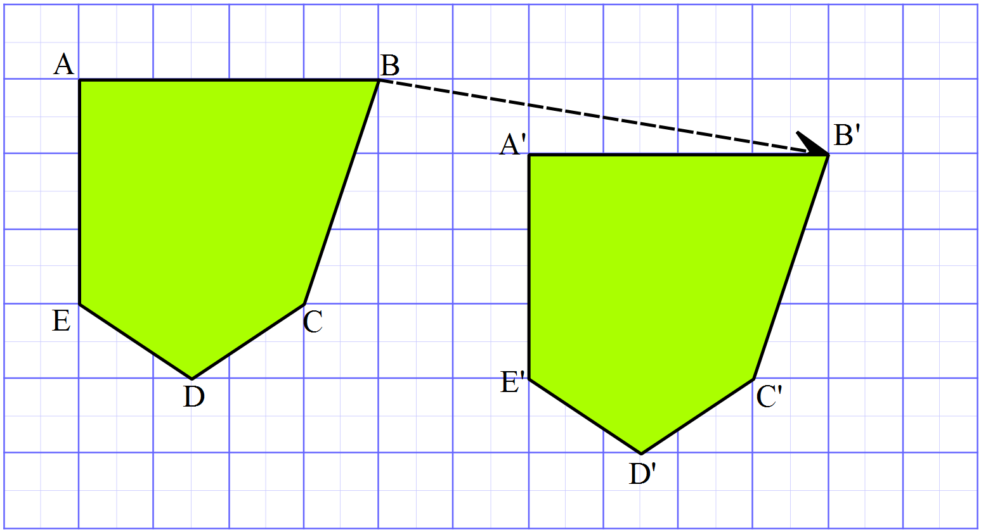 |  | See Diagram
 | They may both be right angled, but it is not always the case. |  | 4th Answer
 | There are 6 axes as shown  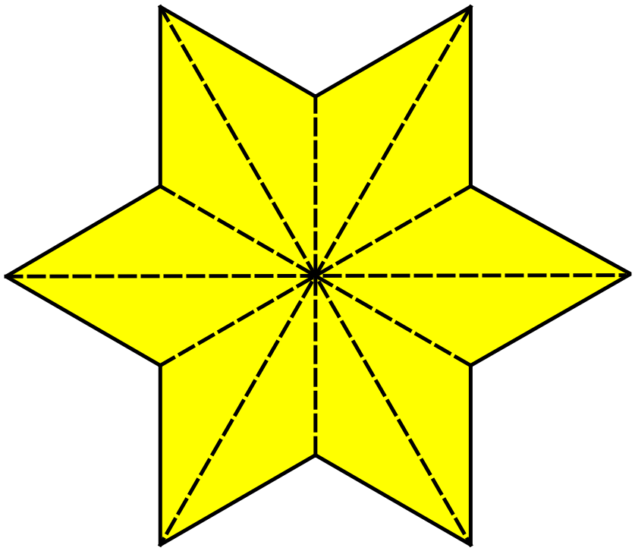 |  | 6
 | Order 6 as each point can be rotated to a new position and it still looks the same. |  | 3rd Answer
 | 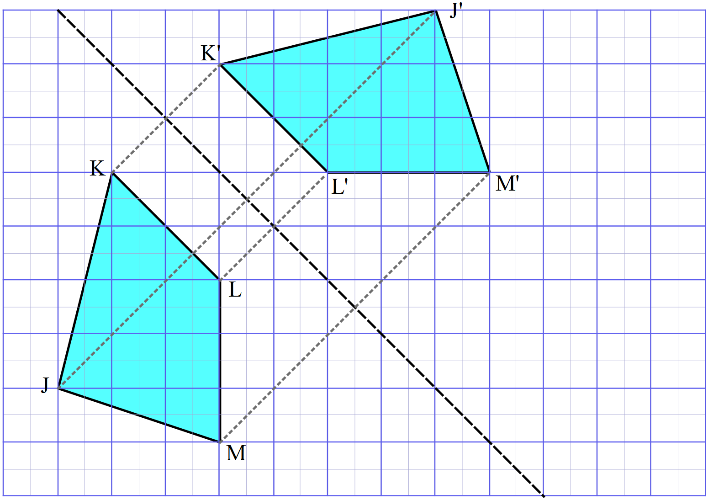 |  | See diagram
 | Order 2 as it can be rotated through 180º and still appears the same. |  | 1st Answer
 | 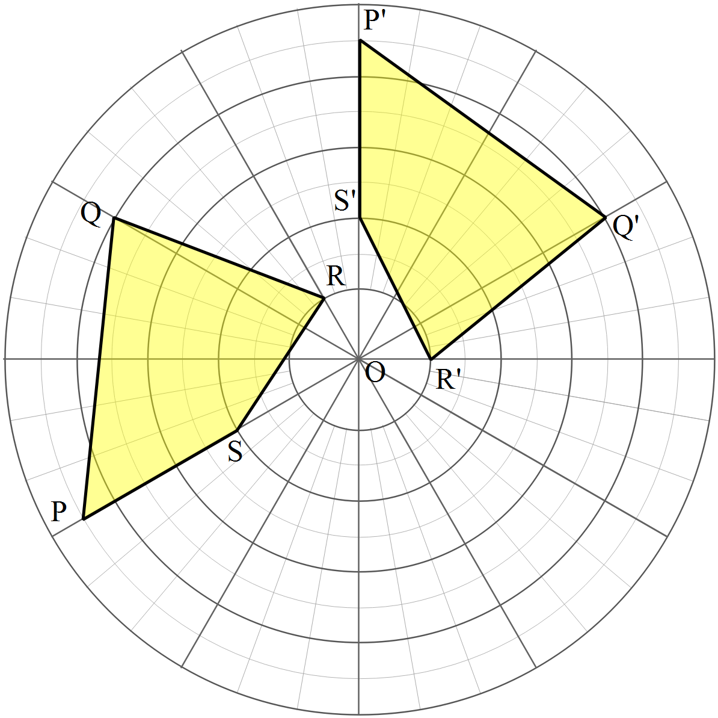  - |  | See Diagram
 | 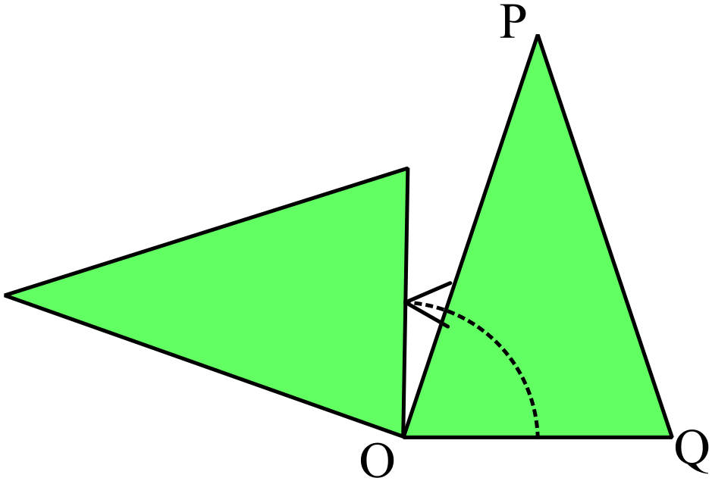 |  | 2nd Answer
 | It is a translation  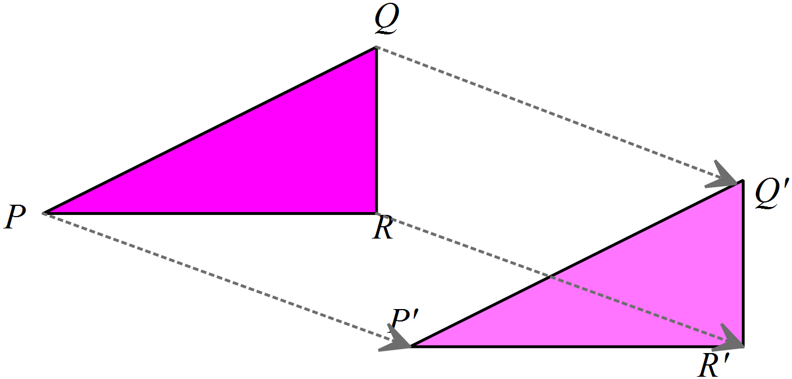 |  | 3rd answer
 | The heptagon with 7 sides has rotational symmetry of order 7. |  | 3rd answer
 | 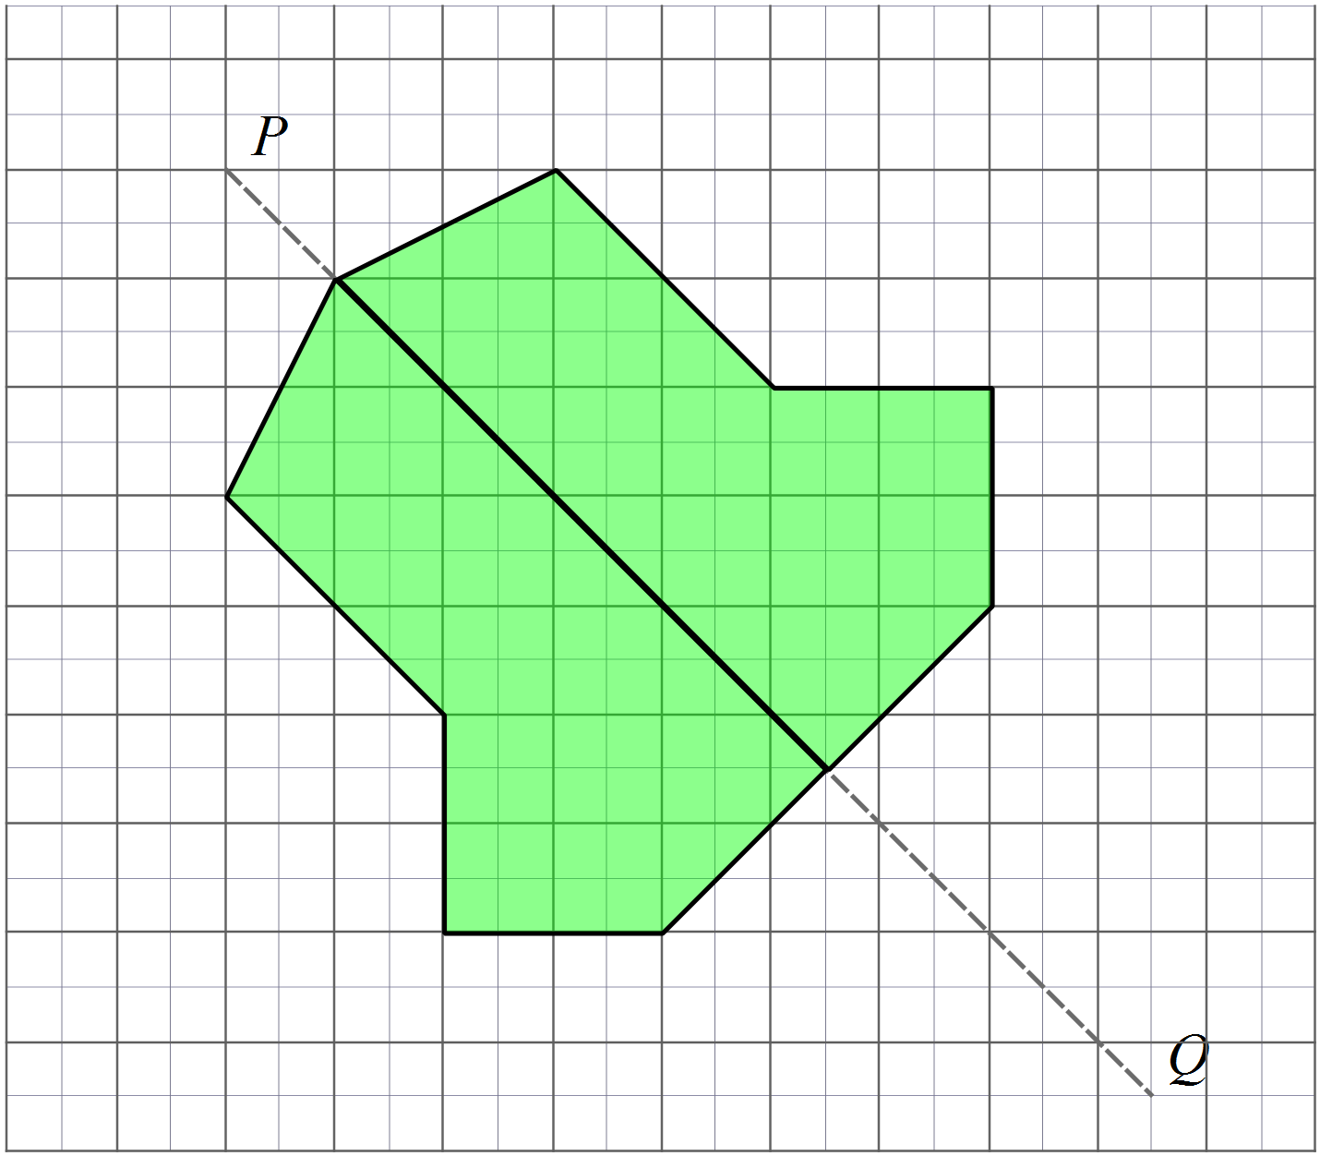 |  | See diagram
 | 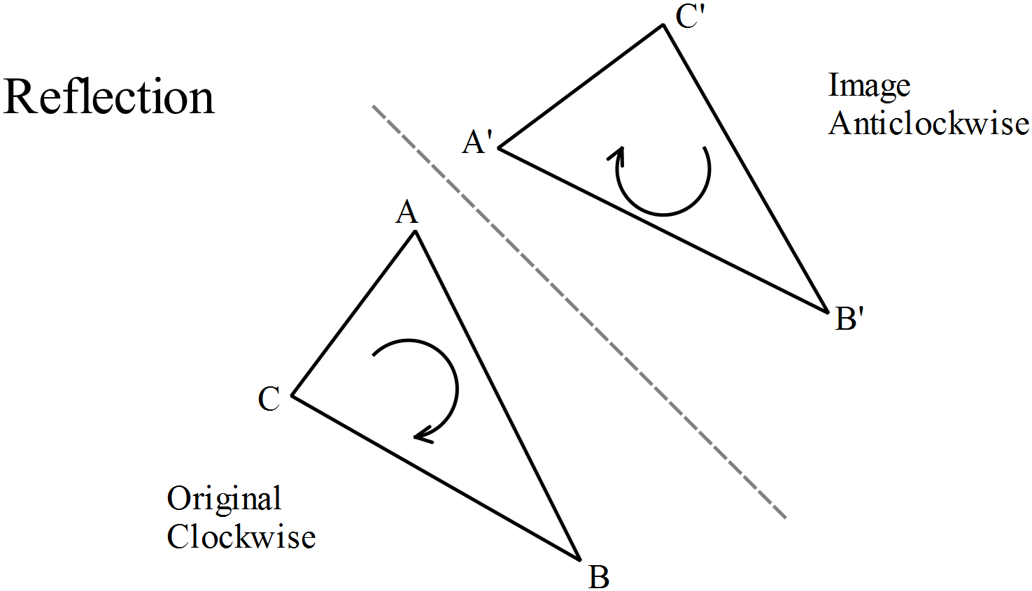 |  | 1st answer
 | 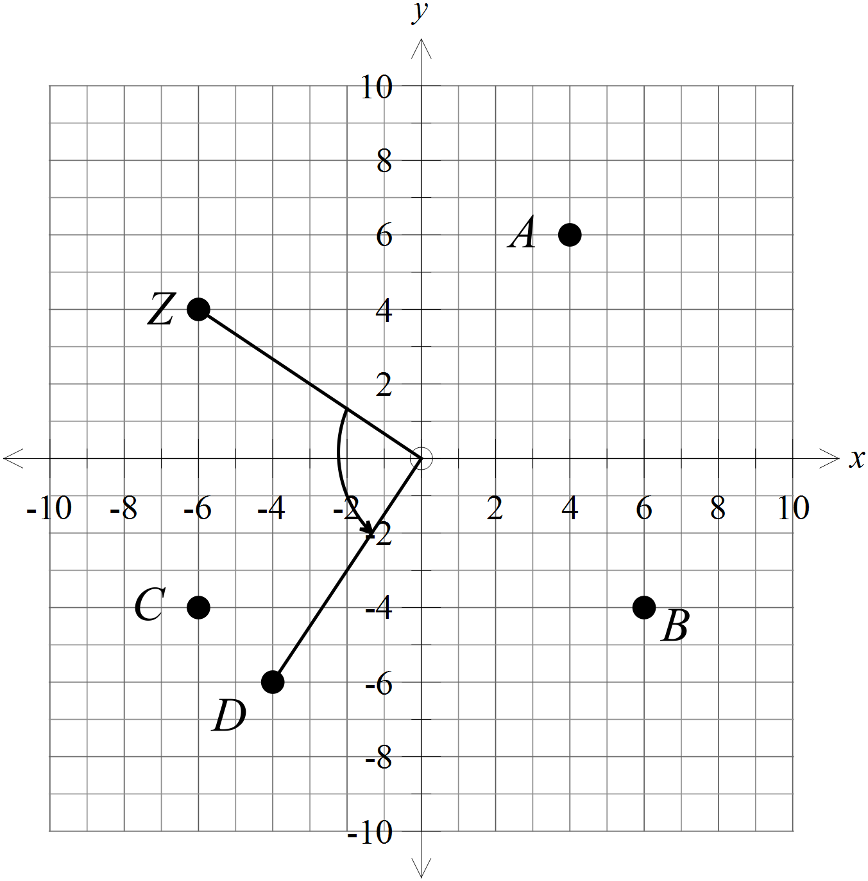 |  | 4th answer
 | 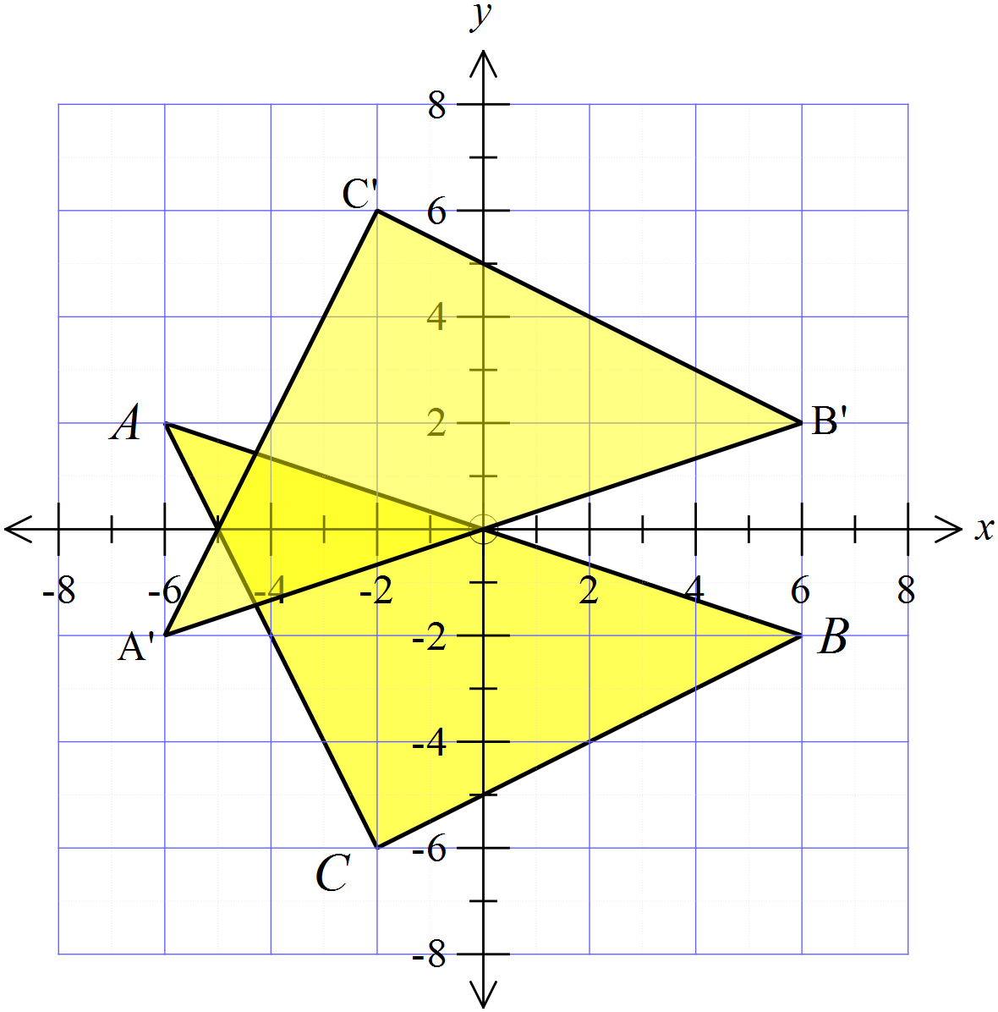 |  | See diagram
 | 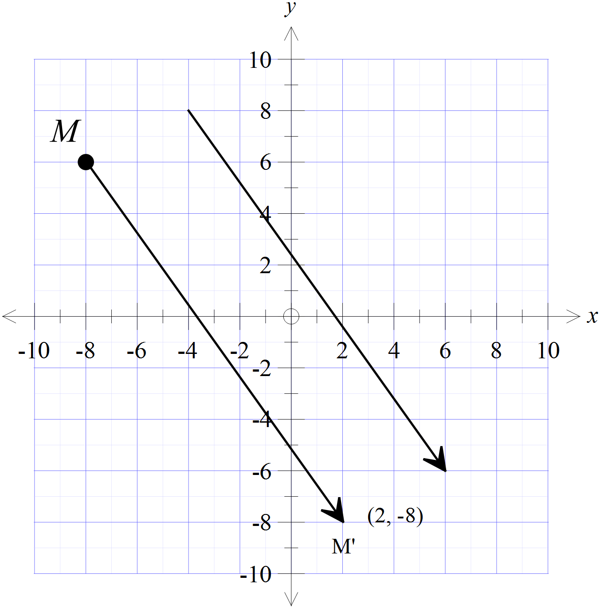 |  | (2, -8)
 | 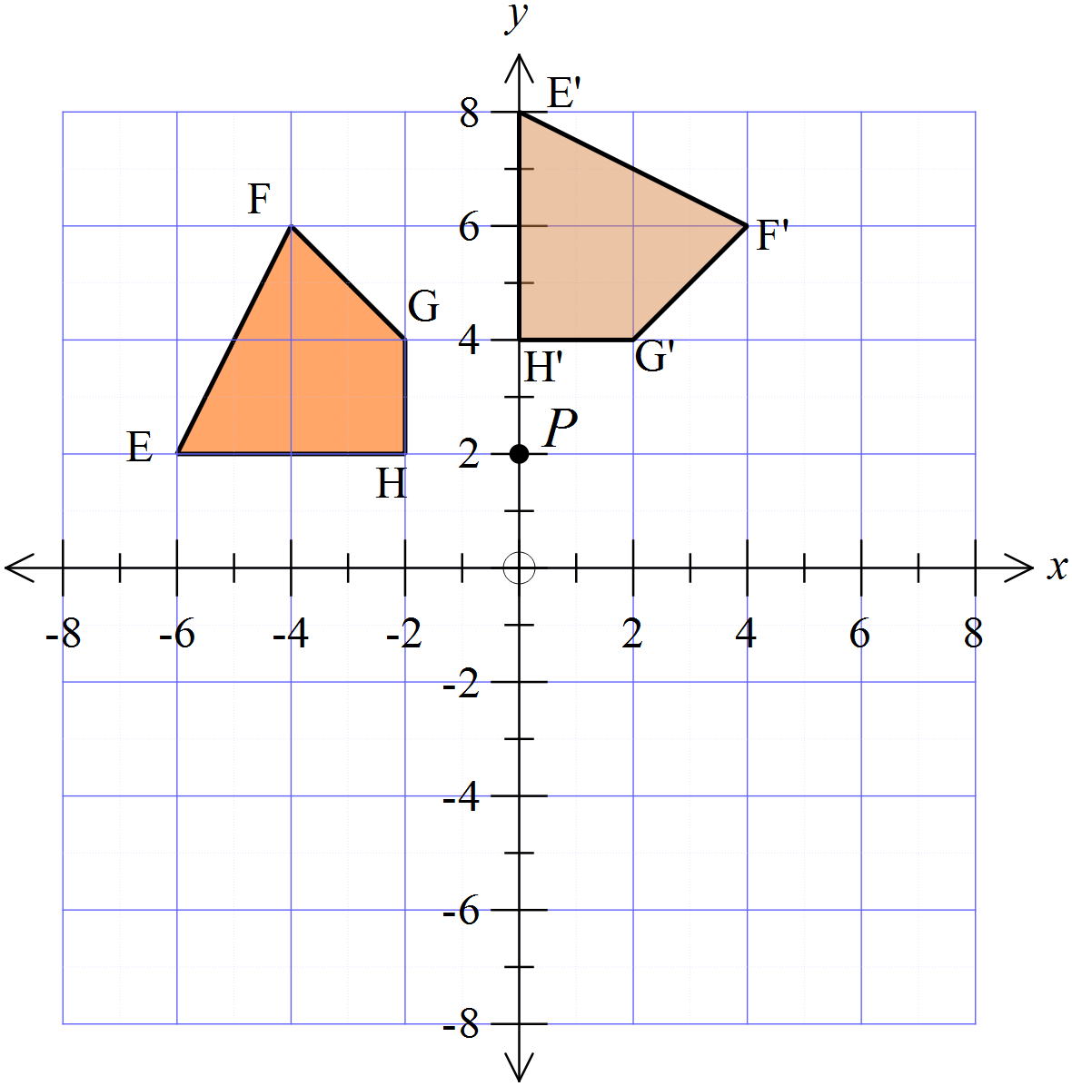 |  | See diagram
 | 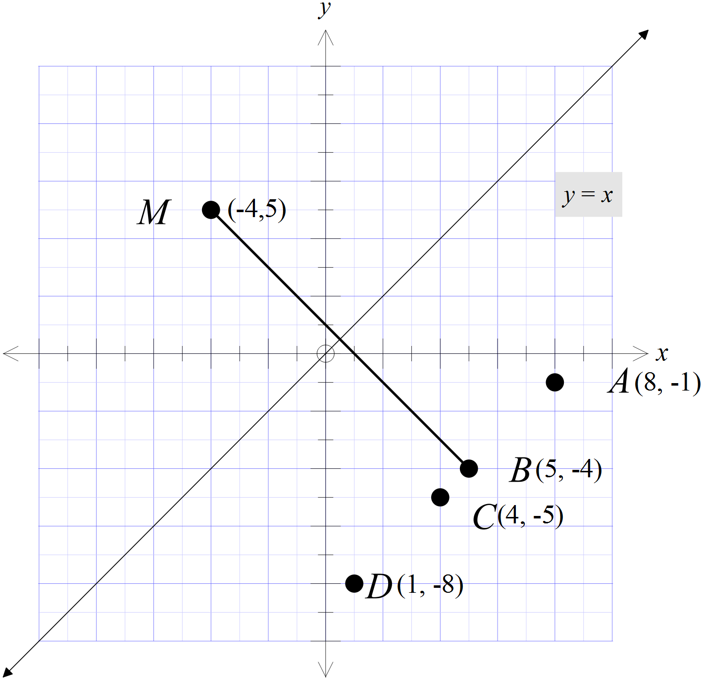 |  | 2nd Answer
 | 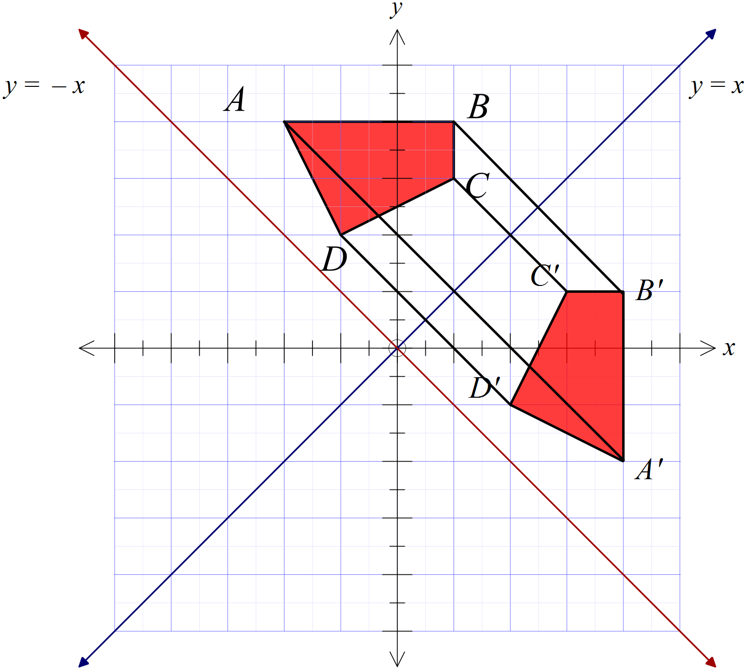  Reflection in the line y = x. |  | 1st answer
 | 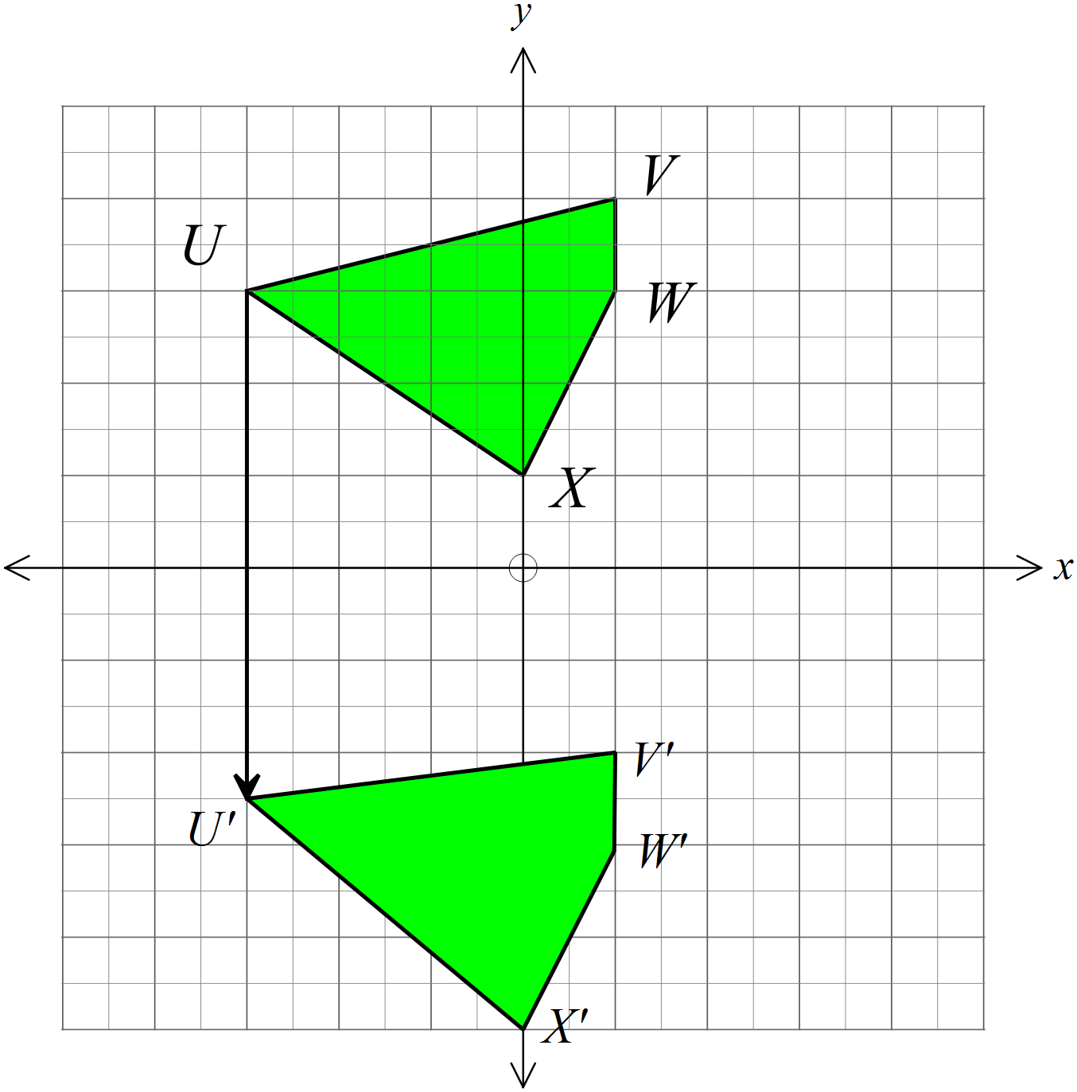  A translation in the direction of the y axis. |  | 4th answer
 | 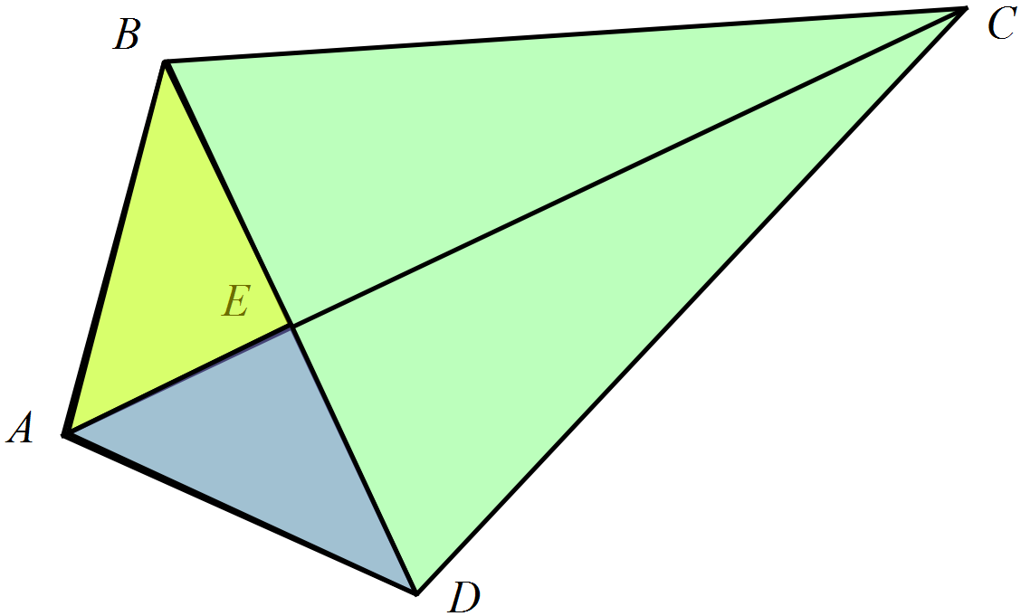 |  | 3rd answer
 | 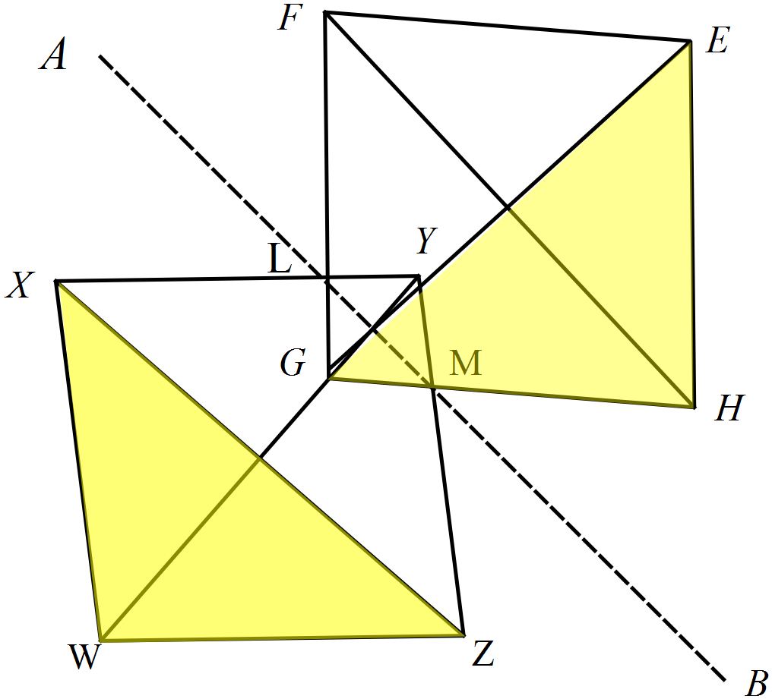  The shaded pair are not congruent |  | 4th answer
 | Reflection in the y axis gives triangle A which is then reflected in the x axis to give triangle B. |  | 2nd answer
 | There are two pairs of corresponding sides equal with the included angle also equal.  SAS |  | 3rd answer
 | 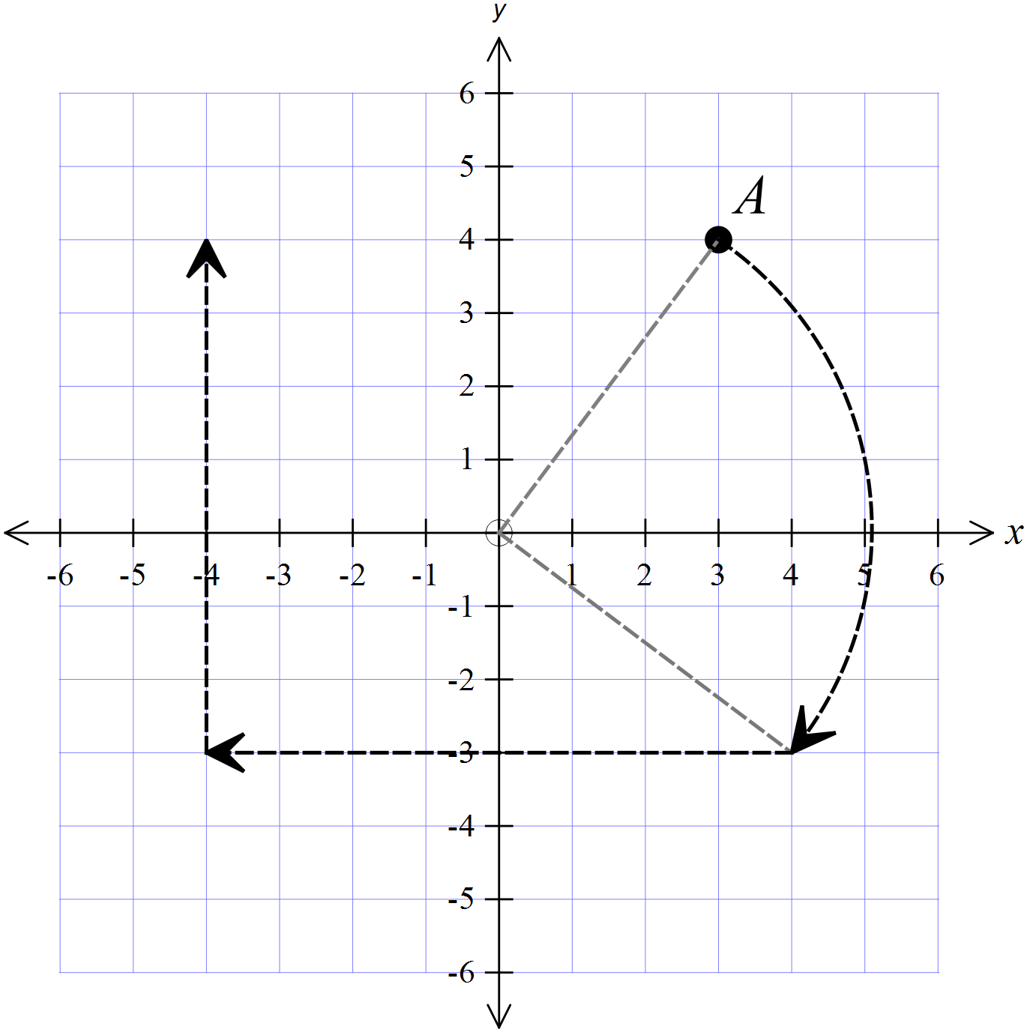 |  | (-4, 4)
 | AC = DF ( allows for SAS) |  | AC = DF
 | Two angles and a corresponding side (AAS). |  | 1st answer
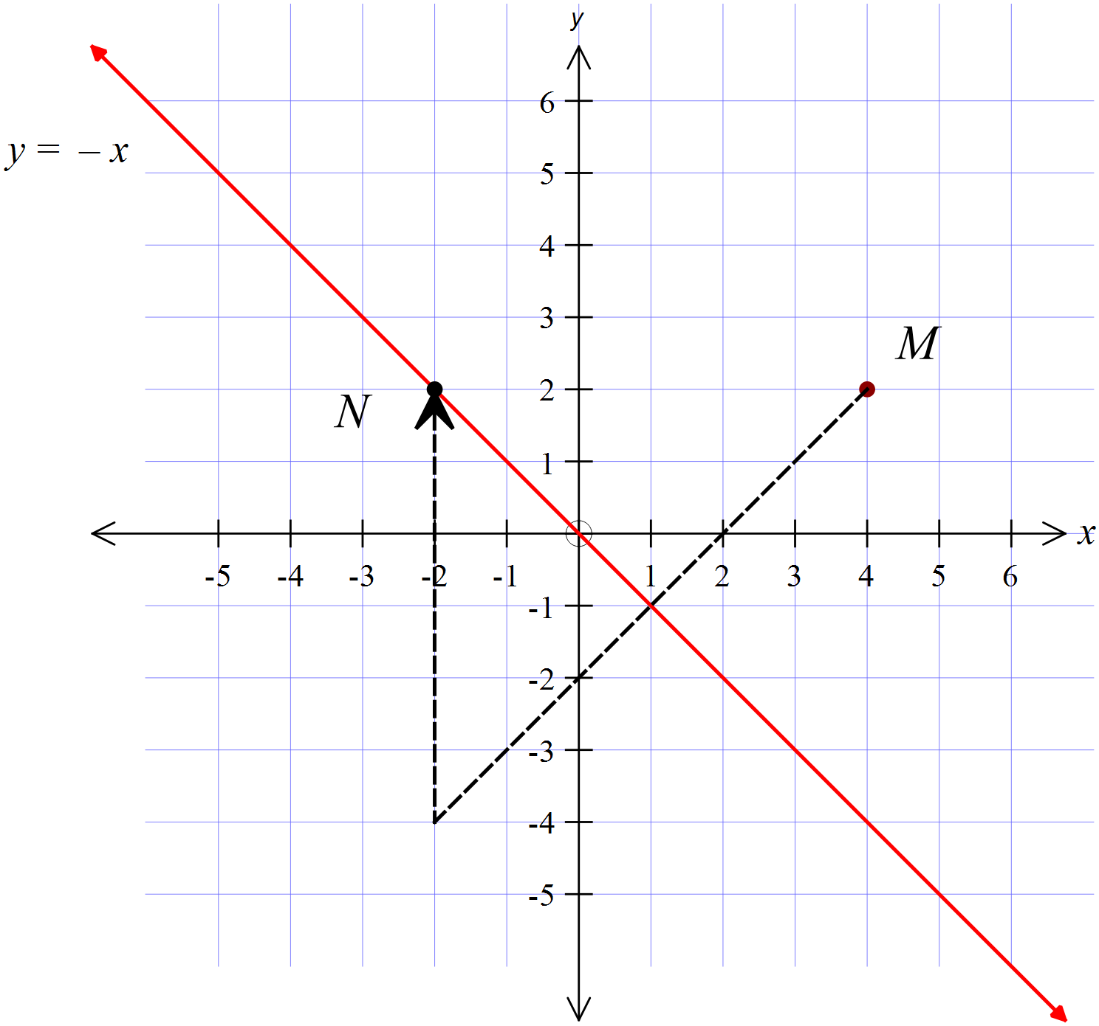

Translation is 6 units directly upward ( direction of the positive y axis)
 | Right angle, hypotenuse and a side in each triangle (RHS) |  | 2nd answer
 | 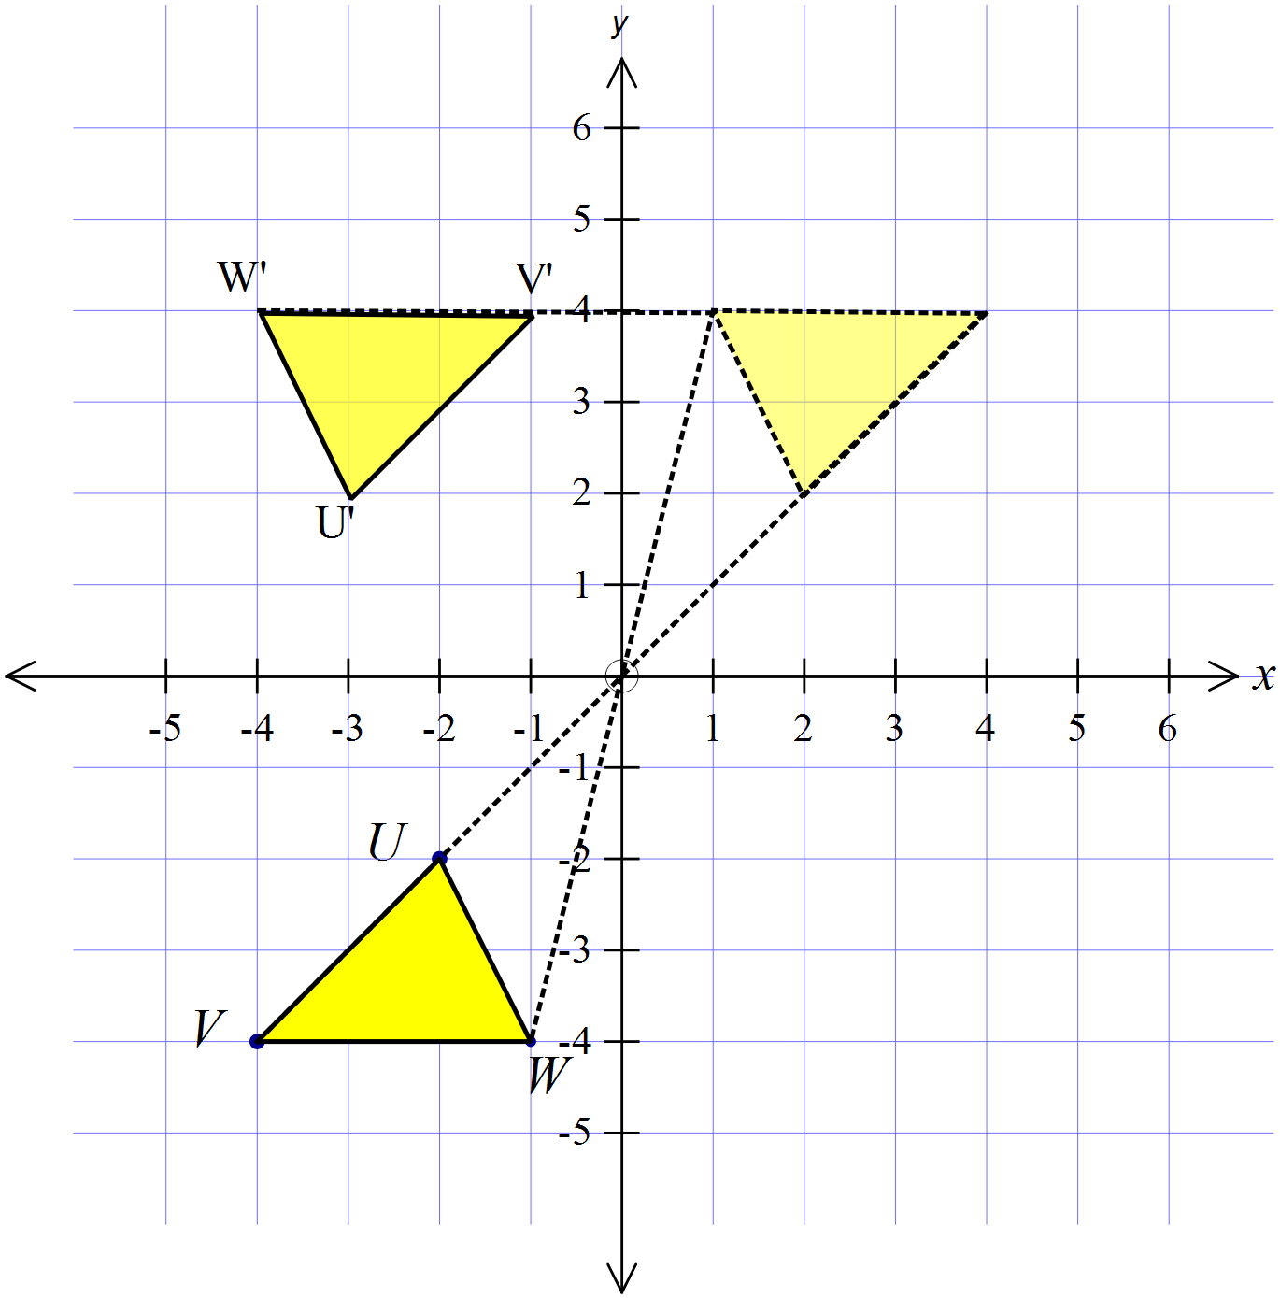 |  | See diagram
 | 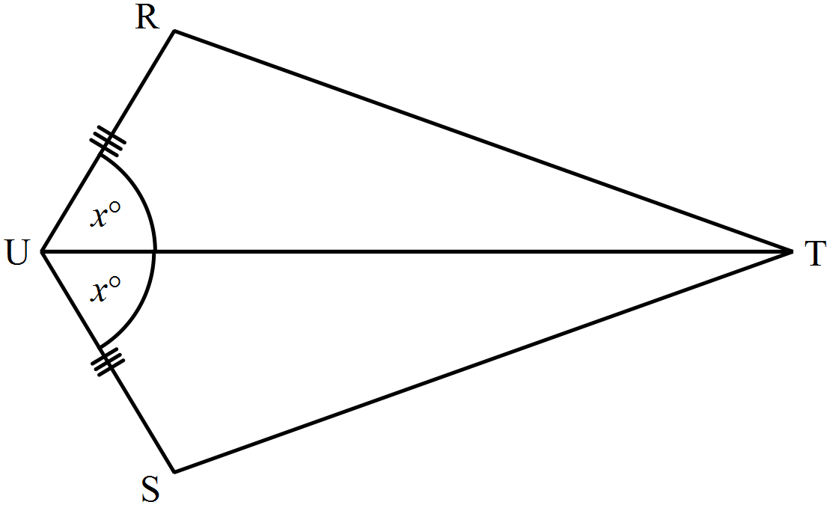  UT is common  The information gives SAS |  | 3rd answer

Year 8 |  | Transformations and Congruence | Calculator Allowed  Longer Answer  Section
ANSWERS
 |  |  |  | Marks
 | 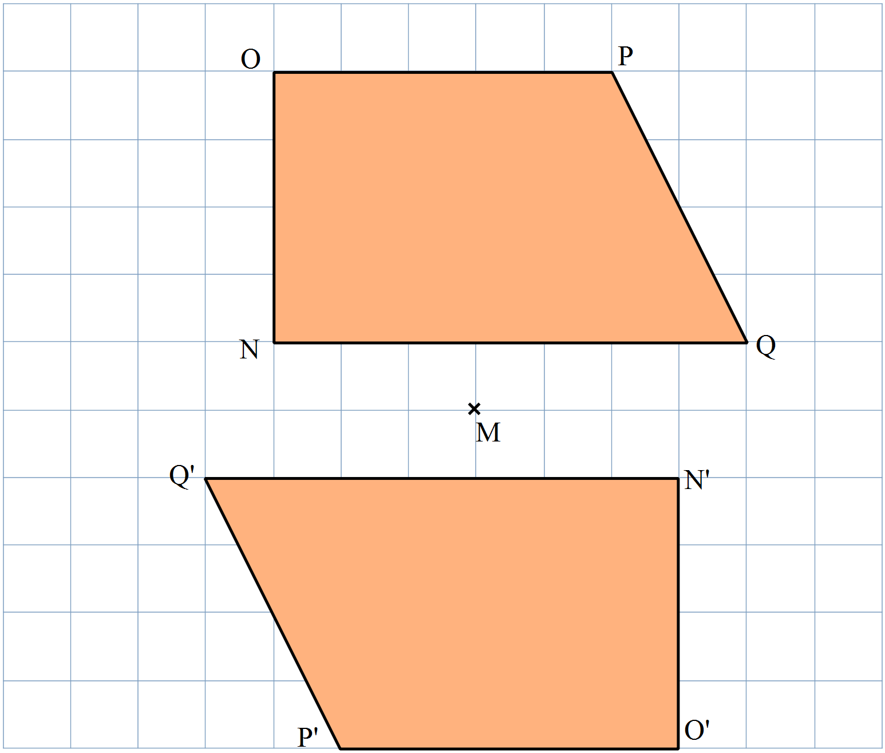(a) |  |  | 2 marks for an accurate drawing.  1 mark if inaccurate or a minor error.
 | (b) (i) See diagram.  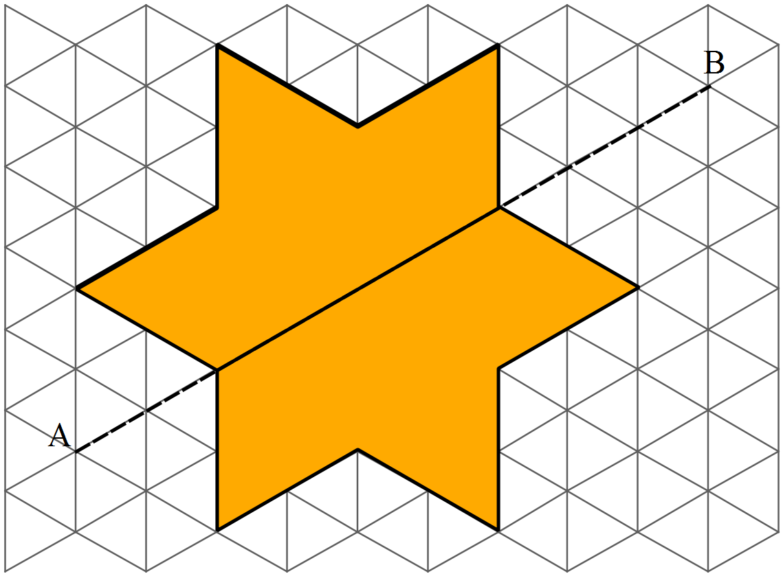  (ii) The figure has rotational symmetry of order 6. |  |  | (i) 2 marks for an accurate drawing.  1 mark if inaccurate or a minor error.  1 mark for answer
 | (a) Draw a figure congruent to ABCD, by translating in the direction and distance indicated by the arrow.  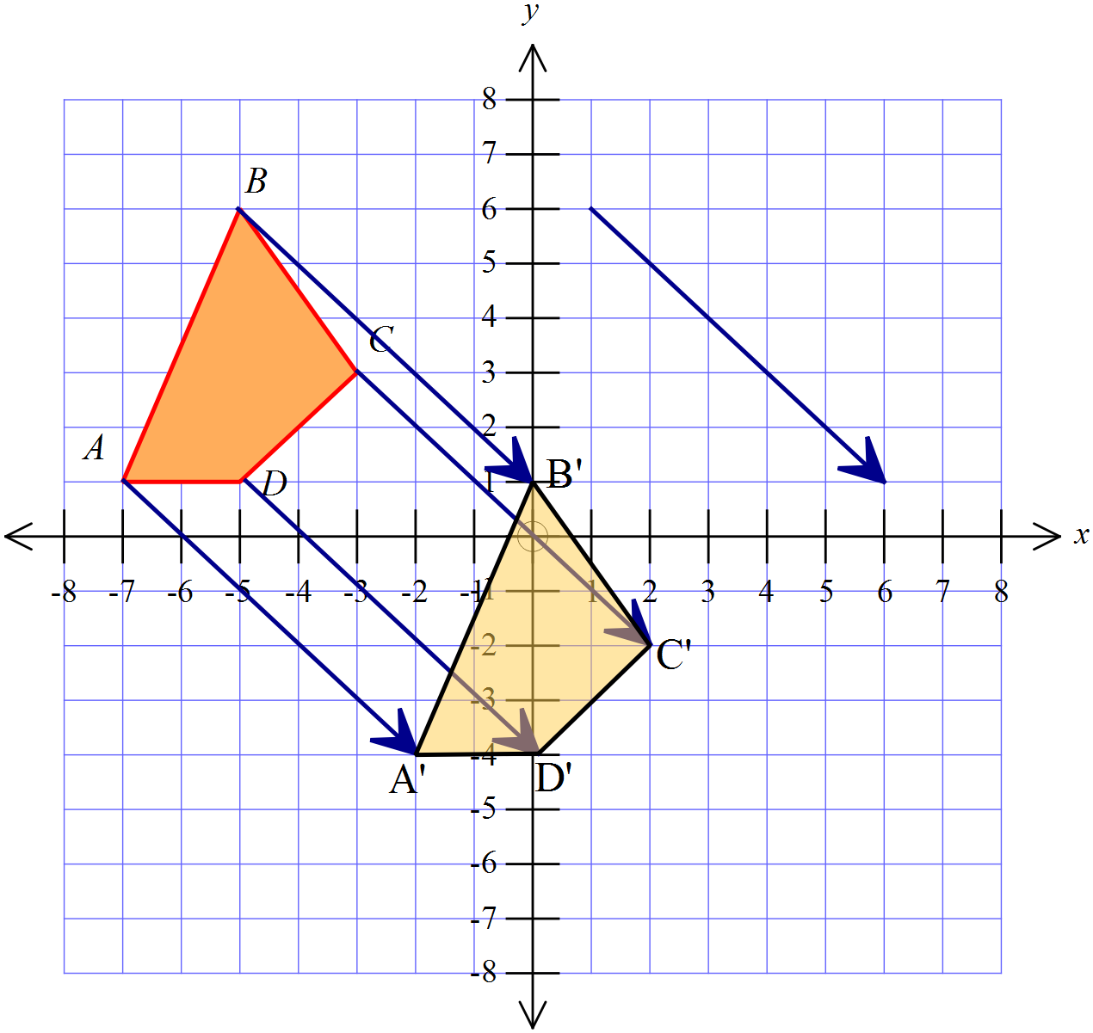 |  |  | 2 marks for an accurate and correct drawing of the image.  1 mark for an inaccurate drawing or one with a minor error
 | 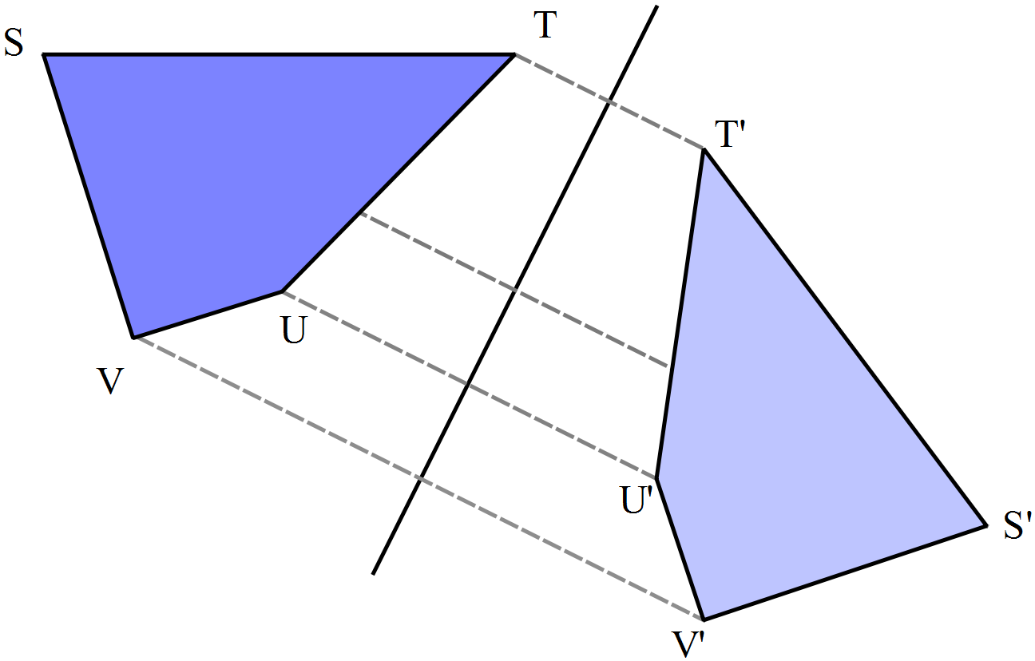(b)  A reflection in the line AB shown. |  |  | 2 marks for stating it is a reflection and drawing in the line, in an approximate position or describing accurately its position.  1 mark for doing only one of the above.
 | (a) 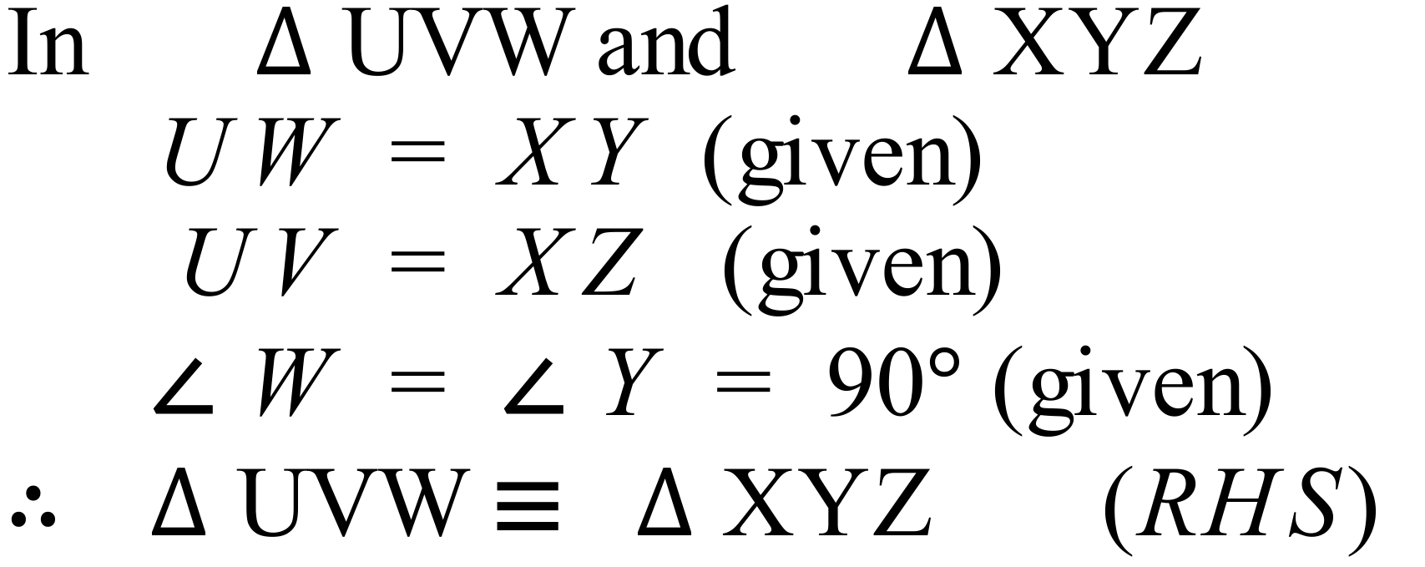 |  |  | 2 marks for stating the three equal features and stating congruence with RHS.  1 mark for a partial proof or incorrect conclusion
 | (b) 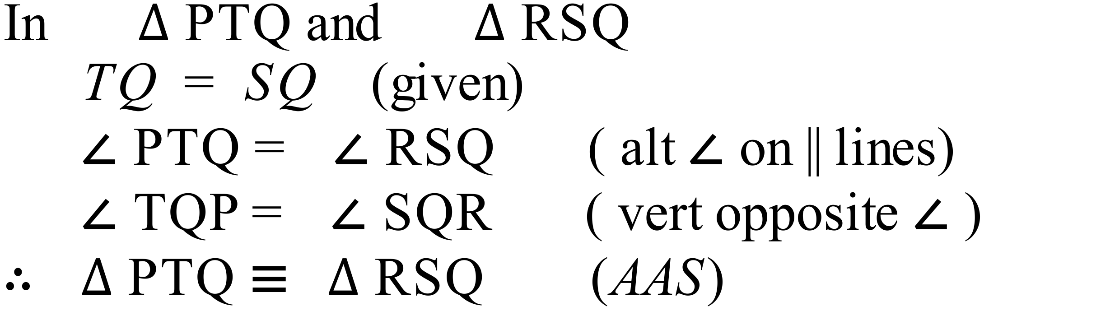 |  |  | 3 marks for stating the three equal features and including the reasons for the two angles being equal and stating congruence with AAS.  2 marks for a proof without one of the reasons or with another minor error or an incorrect conclusion  1 mark for a proof without reasons or incorrect reasons, or which is only a partial attempt at the proof

